# GESTIUNEA UNEI SCOLI

**Ionescu Andreea Raluca**

**Grupa 233**

1. Prezentați pe scurt baza de date (utilitatea ei).

Modelul de date gestioneaza informaţii legate de organizarea şi funcţionarea unei scoli, despre profesori si materiile pe care le predau, despre elevi si notele pe care le au la materiile studiate si despre parintii acestora. De asemenea, prezinta si date precum adresa scolii, a elevilor si parintilor, salile in care se desfasoara orele si ceilalti angajati ai scolii.

La o scoala lucreaza mai multi angajati: gardieni, asistente medicale, oameni de serviciu, secretari, mecanici si profesori. Profesorii pot sa predea mai mult de o materie. Elevii participa la mai multe cursuri la care pot avea mai multe note. O materie se tine mereu in aceeasi sala de clasa indiferent de profesor. Intr-o sala de clasa se pot tine mai multe materii. Fiecare nota are un mark_id si data luarii acelei note.

Sunt mentionate informatii despre domiciliul elevilor, al parintilor, date de contact pentru pentru fiecare, iar elevilor le sunt atribuite adrese de mail speciale de catre scoala de forma „primul_prenume-al_doilea_prenume-nume@initiale_nume_scoala.ro”.

1. 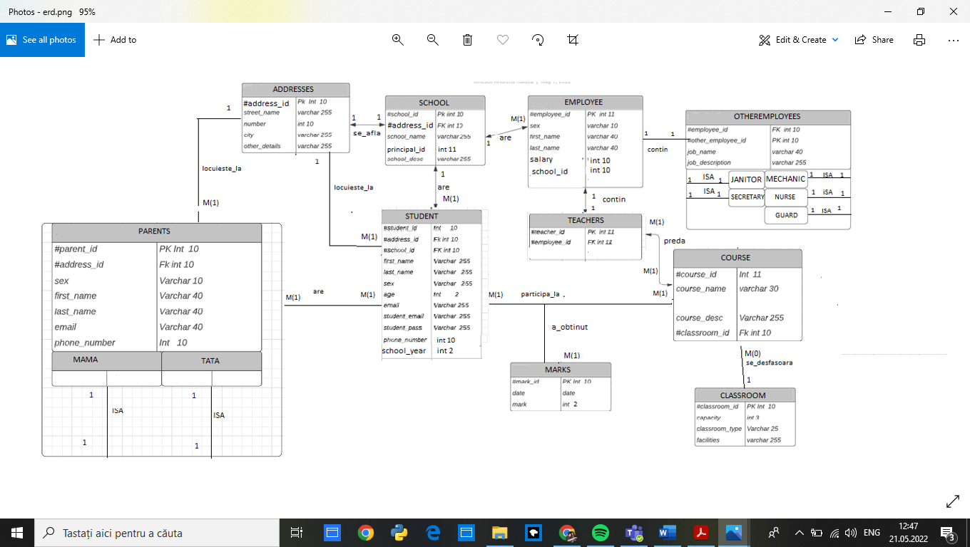Realizați diagrama entitate-relație (ERD).

3. Pornind de la diagrama entitate-relație realizați diagrama conceptuală a modelului propus, integrând

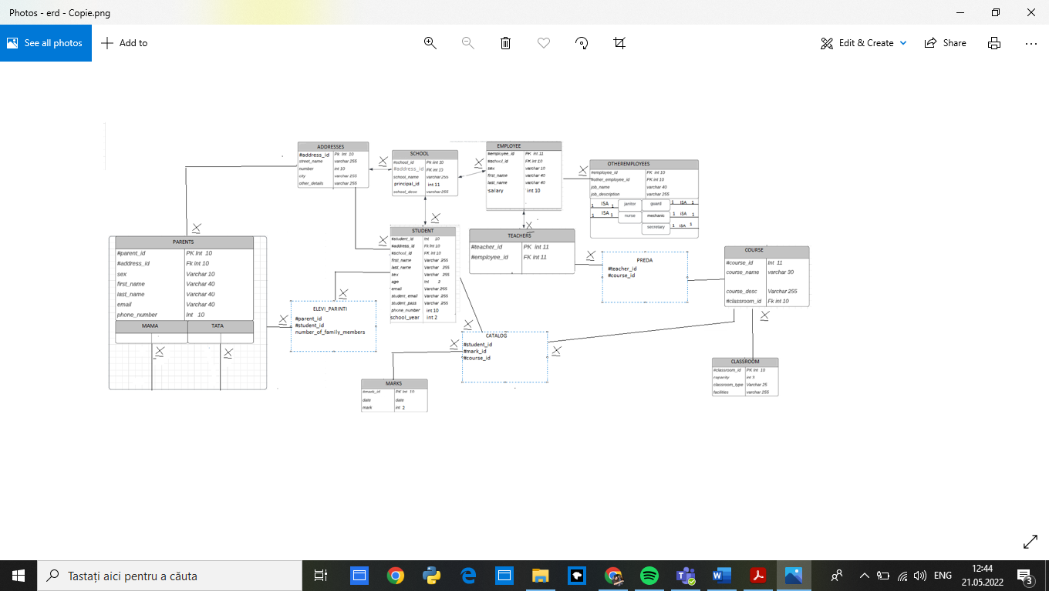toate atributele necesare.

----------------------------------ADDRESSES-----------------------------------

CREATE TABLE ADDRESSES

(

address_id NUMBER(10) CONSTRAINT PKEY_ADDRESS PRIMARY KEY,

street_name VARCHAR(255) CONSTRAINT nume_strada NOT NULL,

number_ NUMBER(10) CONSTRAINT numar_adresa NOT NULL,

city VARCHAR(255) CONSTRAINT nume_oras NOT NULL,

other_details VARCHAR(255) CONSTRAINT detalii_adresa NOT NULL

);

INSERT INTO ADDRESSES

VALUES(1,'Aleea Militari', 22,'Ploiesti','Bloc 12D');

INSERT INTO ADDRESSES

VALUES(2,'Piata Bobalna', 23,'Ploiesti','Nr. 2');

INSERT INTO ADDRESSES

VALUES(3,'Brestei', 18,'Ploiesti','Bloc 7B');

INSERT INTO ADDRESSES

VALUES(4,'Independentei', 22,'Campina','Nr. 123');

INSERT INTO ADDRESSES

VALUES(5,'Cuza Voda', 101,'Ploiesti','Nr. 21');

INSERT INTO ADDRESSES

VALUES(6,'Alexandru Ioan Cuza', 56,'Azuga','Bloc 17A');

INSERT INTO ADDRESSES

VALUES(7,'Mos Ion Roata', 32,'Azuga','Nr. 14');

INSERT INTO ADDRESSES

VALUES(8,'Alexandru Ioan Cuza', 56,'Azuga','Nr.17');

INSERT INTO ADDRESSES

VALUES(9,'Alexandru Odobescu', 99,'Azuga','Bloc 17A');

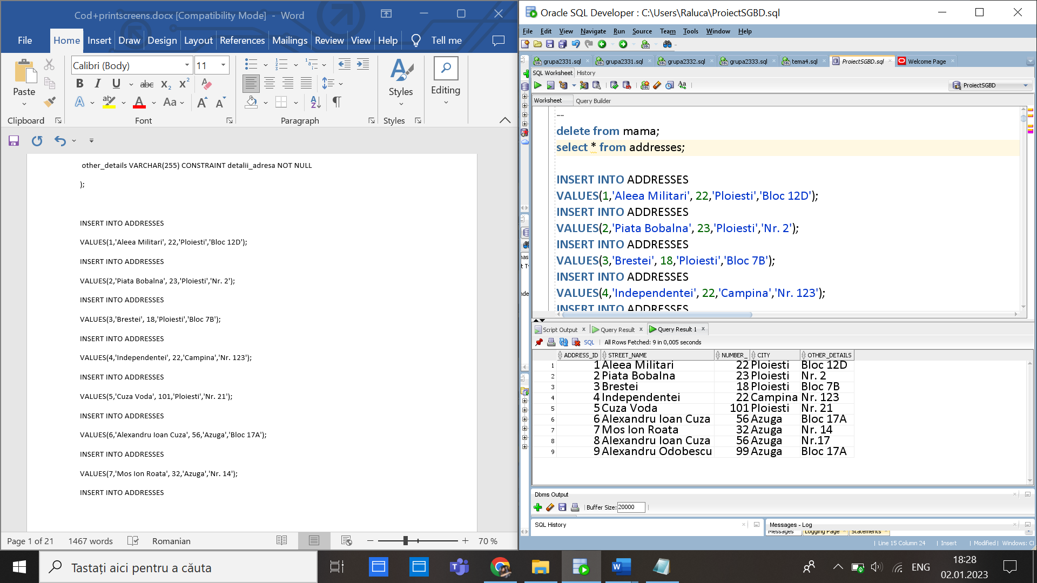

CREATE TABLE SCHOOL

(

school_id NUMBER(10) CONSTRAINT PKEY_SCHOOL PRIMARY KEY,

school_name VARCHAR(255) CONSTRAINT nume_scoala NOT NULL,

principal_id NUMBER(11) CONSTRAINT id_director NOT NULL,

school_desc VARCHAR(255) CONSTRAINT descriere_scoala NOT NULL,

address_id NUMBER(10),

CONSTRAINT fk_address_school FOREIGN KEY (address_id) REFERENCES ADDRESSES(address_id)

);

select * from SCHOOL;

INSERT INTO SCHOOL

VALUES(11,'Sfanta Vineri', 43,'Clase speciale de matematica si informatica',5);

INSERT INTO SCHOOL

VALUES(12,'Sfanta Maria', 42,'Clase speciale de matematica si informatica',7);

INSERT INTO SCHOOL

VALUES(13,'Sfanta Ana', 41,'Clase speciale de informatica si engleza',4);

INSERT INTO SCHOOL

VALUES(14,'Sfanta Vasile', 44,'Clase speciale de germana si engleza',2);

INSERT INTO SCHOOL

VALUES(15,'Sfantul Gheorghe', 45,'Clase speciale de informatica si engleza',8) ;

update school

set principal_id=33

where school_name='Sfanta Vineri';

update school

set principal_id=34

where school_name='Sfanta Maria';

update school

set principal_id=35

where school_name='Sfanta Ana';

update school

set principal_id=37

where school_name='Sfantu Gheorghe';

update school

set school_name='Sfantu Gheorghe'

where school_id=15;

update school

set principal_id=36

where school_name='Sfanta Vasile';

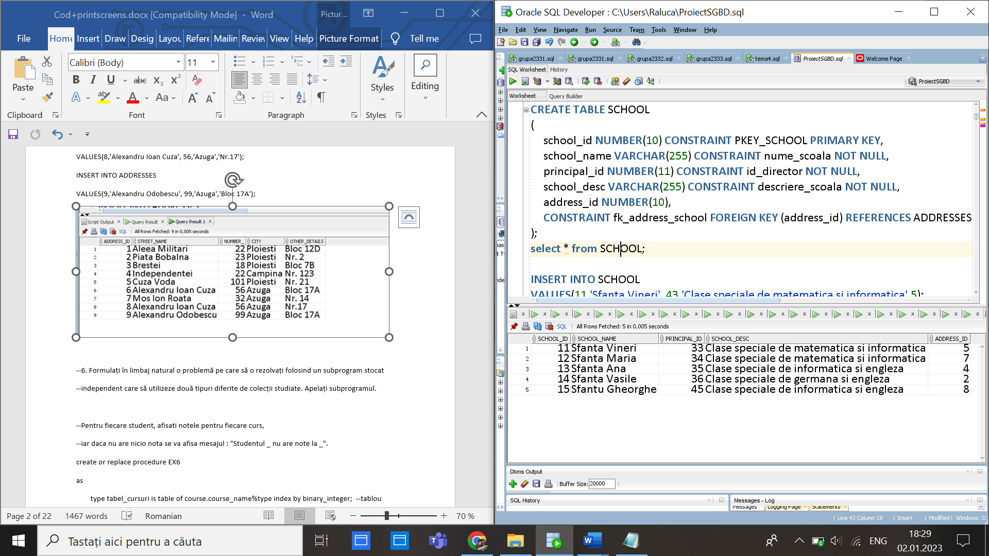

CREATE TABLE STUDENT

(student_id NUMBER(10) CONSTRAINT PKEY_STUDENT PRIMARY KEY,

address_id NUMBER(10),

school_id NUMBER(10),

last_name VARCHAR(255) CONSTRAINT prenume_elev NOT NULL,

first_name VARCHAR(255) CONSTRAINT nume_elev NOT NULL,

sex VARCHAR(255) CONSTRAINT sex_elev NOT NULL,

age NUMBER(2) CONSTRAINT varsta_elev NOT NULL,

email VARCHAR(255) UNIQUE,

student_email VARCHAR(255) UNIQUE,

student_pass VARCHAR(255) UNIQUE,

phone_number1 NUMBER(11) UNIQUE,

school_year NUMBER(2) CONSTRAINT an_scolar_elev NOT NULL,

CONSTRAINT fk_address_student FOREIGN KEY(address_id) references ADDRESSES(address_id),

CONSTRAINT fk_school_student FOREIGN KEY(school_id) references SCHOOL(school_id)

);

select * from STUDENT;

INSERT INTO STUDENT

VALUES(21,1,11,'Ionescu','Raluca','feminin',13,'ionescu_raluca@yahoo.com','raluca-ionescu@sv.ro','9374891',0722222222,7);

INSERT INTO STUDENT

VALUES(22,1,11,'Ionescu','Matei','masculin',12,'ionescu_matei@yahoo.com','matei-ionescu@sv.ro','9325891',0733333333,6);

INSERT INTO STUDENT

VALUES(23,4,13,'Popescu','Alex','masculin',10,'alex_popescu@yahoo.com','alex-popescu@sa.ro','9374521511',0744444444,4);

INSERT INTO STUDENT

VALUES(24,6,15,'Iancu','Andreea','feminin',11,'iancu_andreea@yahoo.com','andreea-iancu@sv.ro','934713591',0755555555,5);

INSERT INTO STUDENT

VALUES(25,3,14,'Gaias','Delia','feminin',14,'gaias_delia@yahoo.com','delia-gaias@sv.ro','93747891',0766666666,8);

INSERT INTO STUDENT

VALUES(26,9,15,'Anghel','Andreea','feminin',11,'anghel_andreea@yahoo.com','andreea-anghel@sv.ro','9347130091',0755575555,5);

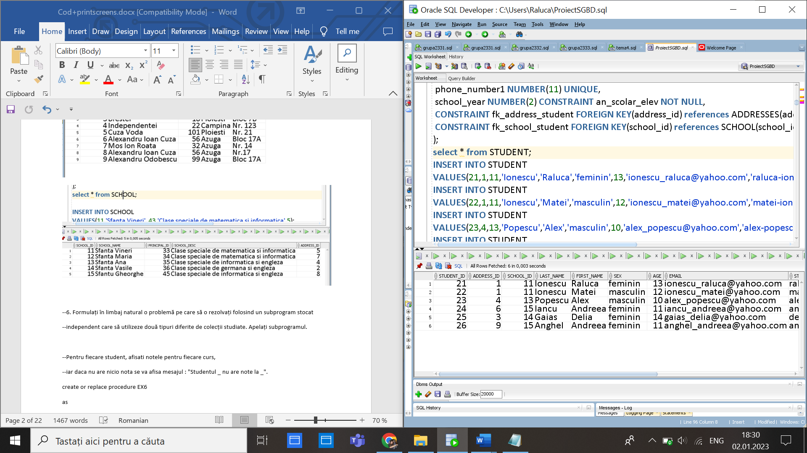

CREATE TABLE EMPLOYEE

(

employee_id NUMBER(11) CONSTRAINT PKEY_EMPLOYEE PRIMARY KEY,

school_id NUMBER(10),

CONSTRAINT fk_school_employee FOREIGN KEY(school_id) references SCHOOL(school_id),

first_name VARCHAR(40) CONSTRAINT prenume_angajat NOT NULL,

last_name VARCHAR(40) CONSTRAINT nume_angajat NOT NULL,

sex VARCHAR(10) CONSTRAINT sex_angajat NOT NULL

);

select * from EMPLOYEE;

--profi

update EMPLOYEE

set salary=4600

where employee_id=31;

ALTER TABLE EMPLOYEE

ADD (salary NUMBER(10) DEFAULT 4600);

ALTER TABLE EMPLOYEE

ADD CONSTRAINT salariu_angajat NOT NULL (salary) ;

update employee

set salary=salary+20/100*salary

where employee_id=34 or employee_id=38 or employee_id=42

or employee_id=41 or employee_id=52

or employee_id=48 or employee_id=39

or employee_id=49 or employee_id=51;

INSERT INTO EMPLOYEE

VALUES(31,11,'Simache','Catalin','masculin');

INSERT INTO EMPLOYEE

VALUES(32,11,'Cristea','Daniel','masculin');

INSERT INTO EMPLOYEE

VALUES(33,11,'Mocanu','Alexandru','masculin');

INSERT INTO EMPLOYEE

VALUES(34,12,'Radu','Andrei','masculin');

INSERT INTO EMPLOYEE

VALUES(35,13,'Manole','Ioana','feminin');

INSERT INTO EMPLOYEE

VALUES(36,14,'Ciobanu','Diana','feminin');

INSERT INTO EMPLOYEE

VALUES(37,15,'Stanescu','Delia','feminin');

INSERT INTO EMPLOYEE

VALUES(38,11,'Radu','Bianca','feminin');

INSERT INTO EMPLOYEE

VALUES(39,12,'Borindel','Alina','feminin');

INSERT INTO EMPLOYEE

VALUES(40,13,'Gheorghe','Matei','feminin');

--alti angajati----

INSERT INTO EMPLOYEE

VALUES(41,11,'Anghel','Ana','feminin');

INSERT INTO EMPLOYEE

VALUES(42,12,'Poposcu','Briana','feminin');

INSERT INTO EMPLOYEE

VALUES(43,13,'Iordache','Bogdan','masculin');

INSERT INTO EMPLOYEE

VALUES(44,14,'Manolache','George','masculin');

INSERT INTO EMPLOYEE

VALUES(45,12,'Ionescu','Maria','feminin');

INSERT INTO EMPLOYEE

VALUES(46,15,'Iordache','Mihaela','feminin');

INSERT INTO EMPLOYEE

VALUES(47,14,'Catargiu','Costel','masculin');

INSERT INTO EMPLOYEE

VALUES(48,13,'Suciu','Ana','feminin');

INSERT INTO EMPLOYEE

VALUES(49,12,'Ganea','Artur','masculin');

INSERT INTO EMPLOYEE

VALUES(50,11,'Mocanu','Sandu','masculin');

INSERT INTO EMPLOYEE

VALUES(51,14,'Barbu','Dimitrie','masculin');

INSERT INTO EMPLOYEE

VALUES(52,13,'Gheorghiu','Antonio','masculin');

INSERT INTO EMPLOYEE

VALUES(53,12,'Poenaru','Antonio','masculin');

INSERT INTO EMPLOYEE

VALUES(54,11,'Filotti','Flaviu','masculin');

INSERT INTO EMPLOYEE

VALUES(55,15,'Mitu','Ion','masculin');

INSERT INTO EMPLOYEE

VALUES(56,15,'Manolache','Ionut','masculin',4600);

INSERT INTO EMPLOYEE

VALUES(57,15,'Manole','Ioana','feminin',4600);

INSERT INTO EMPLOYEE

VALUES(58,14,'Ciobanu','Diana','feminin',4600);

INSERT INTO EMPLOYEE

VALUES(59,15,'Mocanu','Alex','masculin',4600);

INSERT INTO EMPLOYEE

VALUES(60,15,'Mocanu','Alex','masculin',4600);

INSERT INTO EMPLOYEE

VALUES(61,15,'Radu','Andrei','masculin',4600);

INSERT INTO EMPLOYEE

VALUES(62,13,'Simache','Catalin','masculin',4600);

INSERT INTO EMPLOYEE

VALUES(65,13,'Toma','Adrian','masculin',4600);

INSERT INTO EMPLOYEE

VALUES(63,10,'Andrei','Simona','feminin',4600);

INSERT INTO EMPLOYEE

VALUES(64,13,'Toma','Cristian','masculin',4600);

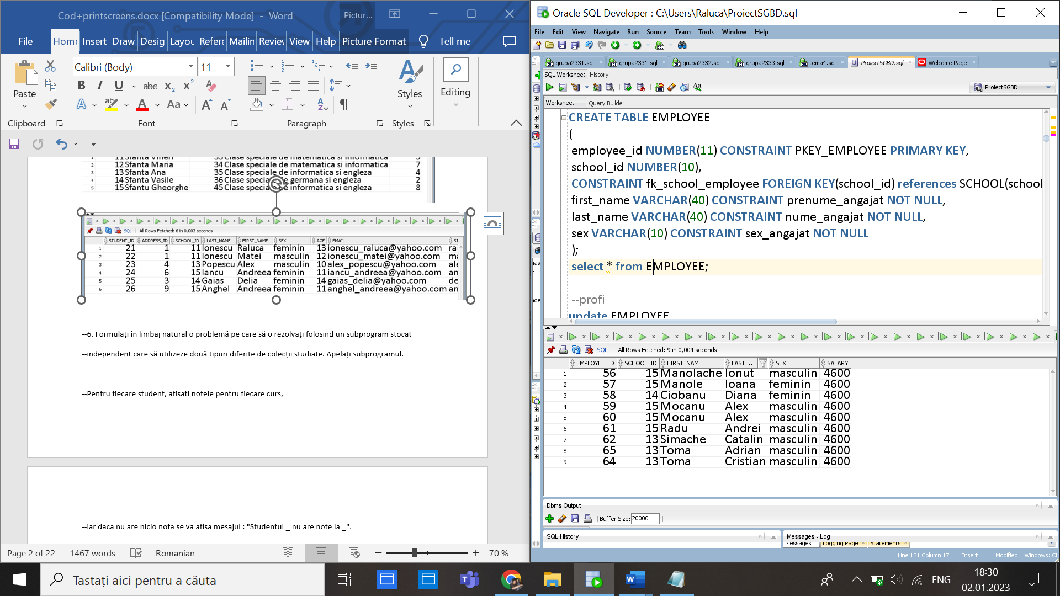

CREATE TABLE OTHEREMPLOYEES

(

other_employee_id NUMBER(10) CONSTRAINT PKEY_OTHEREMPLOYEE PRIMARY KEY,

employee_id NUMBER(10),

CONSTRAINT fk_otheremployee FOREIGN KEY(employee_id) references EMPLOYEE(employee_id),

job_name VARCHAR(40) CONSTRAINT nume_alt_angajat NOT NULL,

job_description VARCHAR(255) NOT NULL

);

select * from OTHEREMPLOYEES;

INSERT INTO OTHEREMPLOYEES

VALUES(501,41,'Janitor','Responsabil pentru cladirea nordica');

INSERT INTO OTHEREMPLOYEES

VALUES(502,42,'Janitor','Responsabil pentru cladirea nordica');

INSERT INTO OTHEREMPLOYEES

VALUES(503,43,'Janitor','Responsabil pentru cladirea sudica');

INSERT INTO OTHEREMPLOYEES

VALUES(504,44,'Janitor','Responsabil pentru cladirea sudica');

INSERT INTO OTHEREMPLOYEES

VALUES(505,46,'Nurse','Asistenta medicala la cabinetul stomatologic.');

INSERT INTO OTHEREMPLOYEES

VALUES(506,45,'Nurse','Asistenta medicala la cabinetul medical.');

INSERT INTO OTHEREMPLOYEES

VALUES(507,47,'Nurse','Asistenta medicala la cabinetul medical.');

INSERT INTO OTHEREMPLOYEES

VALUES(508,48,'Nurse','Asistenta medicala la cabinetul stomatologic.');

INSERT INTO OTHEREMPLOYEES

VALUES(509,49,'Guardian','Gardian la poarta de la aripa sudica.');

INSERT INTO OTHEREMPLOYEES

VALUES(510,50,'Guardian','Gardian la poarta de la aripa nordica.');

INSERT INTO OTHEREMPLOYEES

VALUES(511,51,'Secretary','Angajat part-time.');

INSERT INTO OTHEREMPLOYEES

VALUES(512,52,'Mechanic','Angajat part-time.');

INSERT INTO OTHEREMPLOYEES

VALUES(513,53,'Mechanic','Responsabil cladirea sudica.');

INSERT INTO OTHEREMPLOYEES

VALUES(514,54,'Mechanic','Angajata part-time.');

INSERT INTO OTHEREMPLOYEES

VALUES(515,55,'Secretary','Responsabil cladirea sudica.');

INSERT INTO OTHEREMPLOYEES

VALUES(516,56,'Janitor','Responsabil pentru cladirea nordica');

INSERT INTO OTHEREMPLOYEES

VALUES(517,57,'Secretary','Responsabil cladirea sudica.');

INSERT INTO OTHEREMPLOYEES

VALUES(518,58,'Secretary','Responsabil cladirea sudica.');

INSERT INTO OTHEREMPLOYEES

VALUES(519,59,'Secretary','Responsabil cladirea sudica.');

INSERT INTO OTHEREMPLOYEES

VALUES(520,60,'Nurse','Asistenta medicala la cabinetul medical.');

INSERT INTO OTHEREMPLOYEES

VALUES(521,61,'Mechanic','Angajata part-time.');

INSERT INTO OTHEREMPLOYEES

VALUES(522,62,'Mechanic','Angajata part-time.');

INSERT INTO OTHEREMPLOYEES

VALUES(523,63,'Guardian','Gardian la poarta de la aripa sudica.');

INSERT INTO OTHEREMPLOYEES

VALUES(524,64,'Guardian','Gardian la poarta de la aripa estica.');

INSERT INTO OTHEREMPLOYEES

VALUES(525,65,'Guardian','Gardian la poarta de la aripa vestica.');

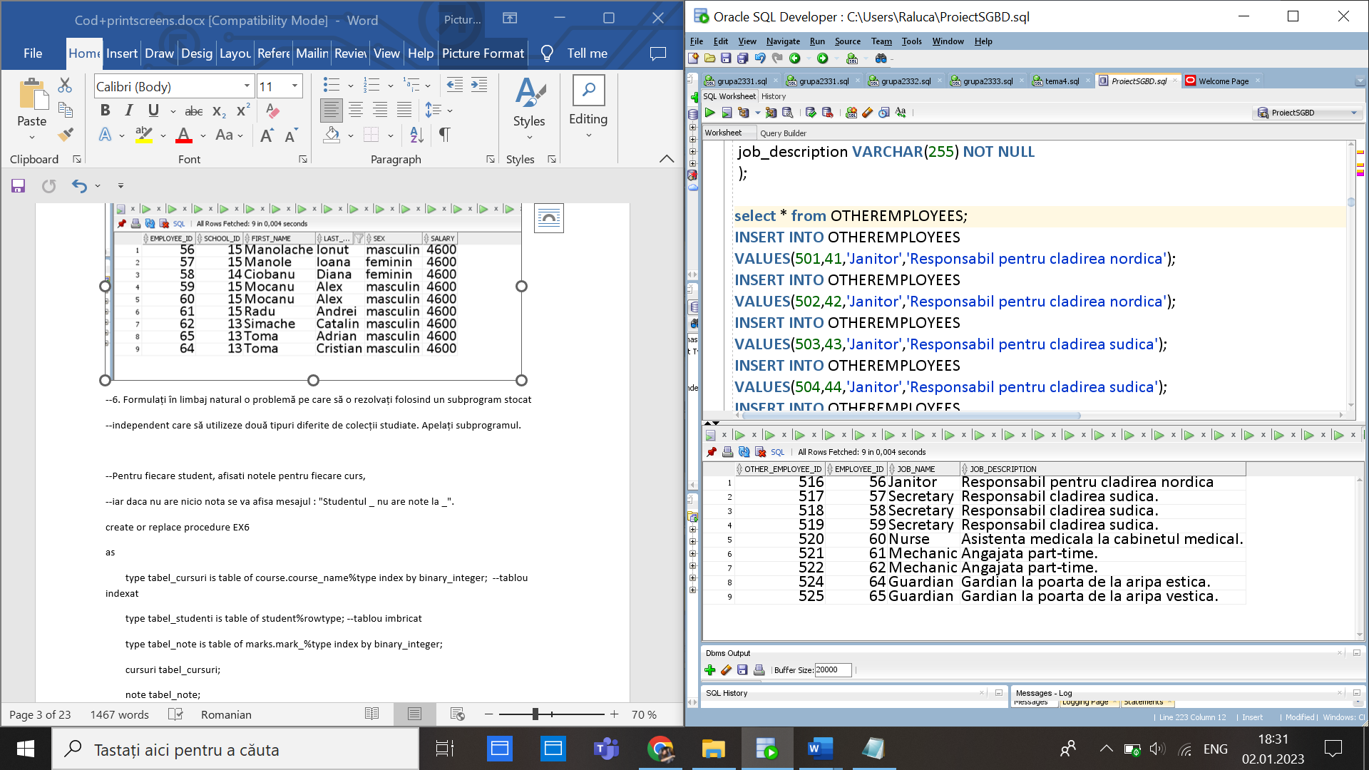

create table SECRETARY

(

secretary_id NUMBER(10) constraint PKEY_SECRETARY PRIMARY KEY,

other_employee_id NUMBER(10),

CONSTRAINT fk_secretary FOREIGN KEY(other_employee_id) references OTHEREMPLOYEES(other_employee_id)

);

select * from SECRETARY;

INSERT INTO SECRETARY

VALUES(605,511);

INSERT INTO SECRETARY

VALUES(604,515);

INSERT INTO SECRETARY

VALUES(605,517);

INSERT INTO SECRETARY

VALUES(606,518);

INSERT INTO SECRETARY

VALUES(607,519);

create table NURSE

(

nurse_id NUMBER(10) constraint PKEY_NURSE PRIMARY KEY,

other_employee_id NUMBER(10),

CONSTRAINT fk_nurse FOREIGN KEY(other_employee_id) references OTHEREMPLOYEES(other_employee_id)

);

select * from NURSE;

INSERT INTO NURSE

VALUES(604,505);

INSERT INTO NURSE

VALUES(605,506);

INSERT INTO NURSE

VALUES(606,507);

INSERT INTO NURSE

VALUES(609,508);

INSERT INTO NURSE

VALUES(610,520);

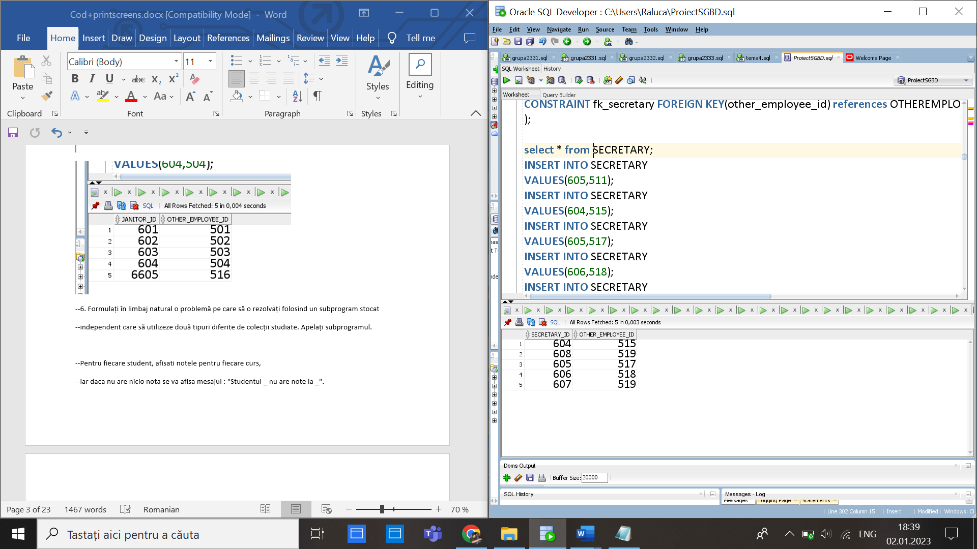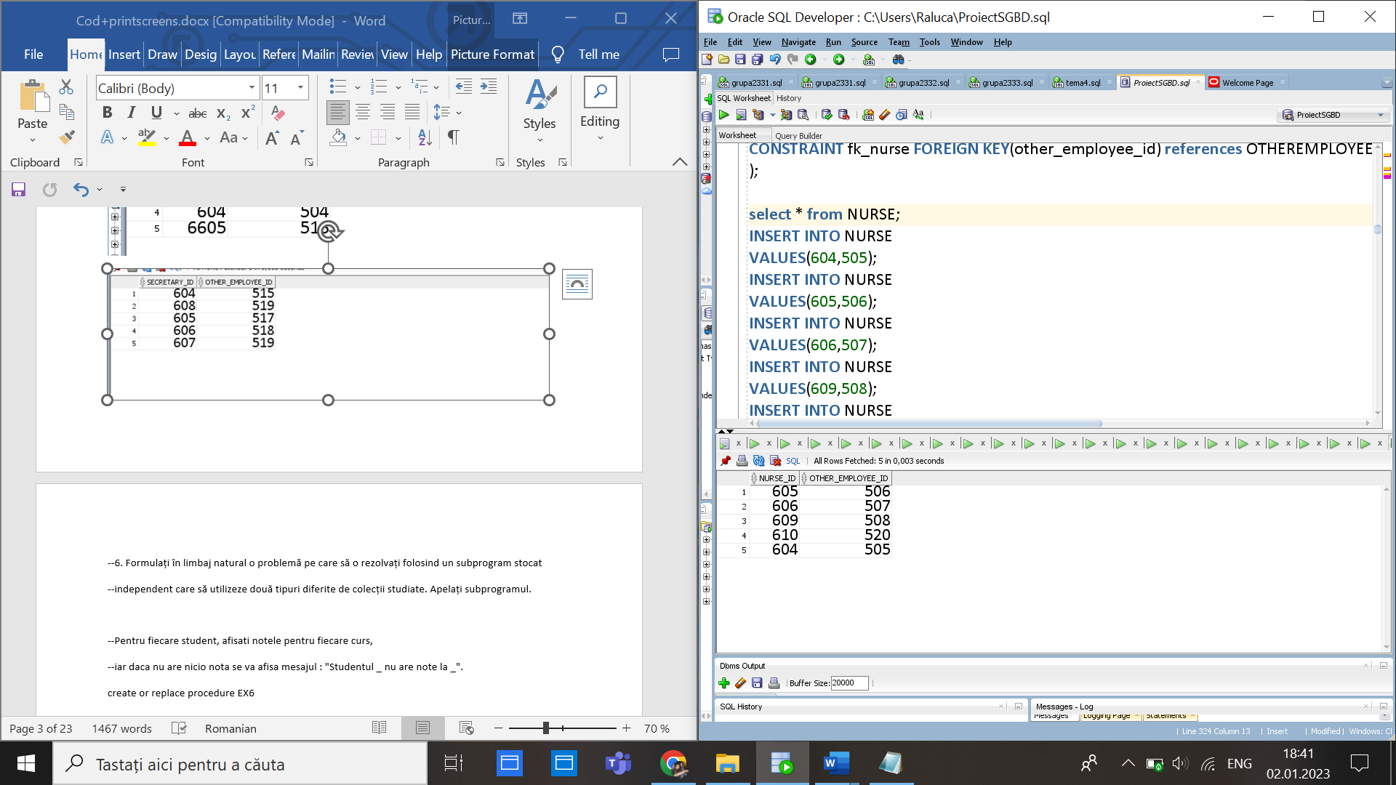

create table MECHANIC

(

mechanic_id NUMBER(10) constraint PKEY_MECHANIC PRIMARY KEY,

other_employee_id NUMBER(10),

CONSTRAINT fk_mechanic FOREIGN KEY(other_employee_id)

references OTHEREMPLOYEES(other_employee_id)

);

select * from MECHANIC;

INSERT INTO MECHANIC

VALUES(610,512);

INSERT INTO MECHANIC

VALUES(611,513);

INSERT INTO MECHANIC

VALUES(612,514);

INSERT INTO MECHANIC

VALUES(613,520);

INSERT INTO MECHANIC

VALUES(614,521);

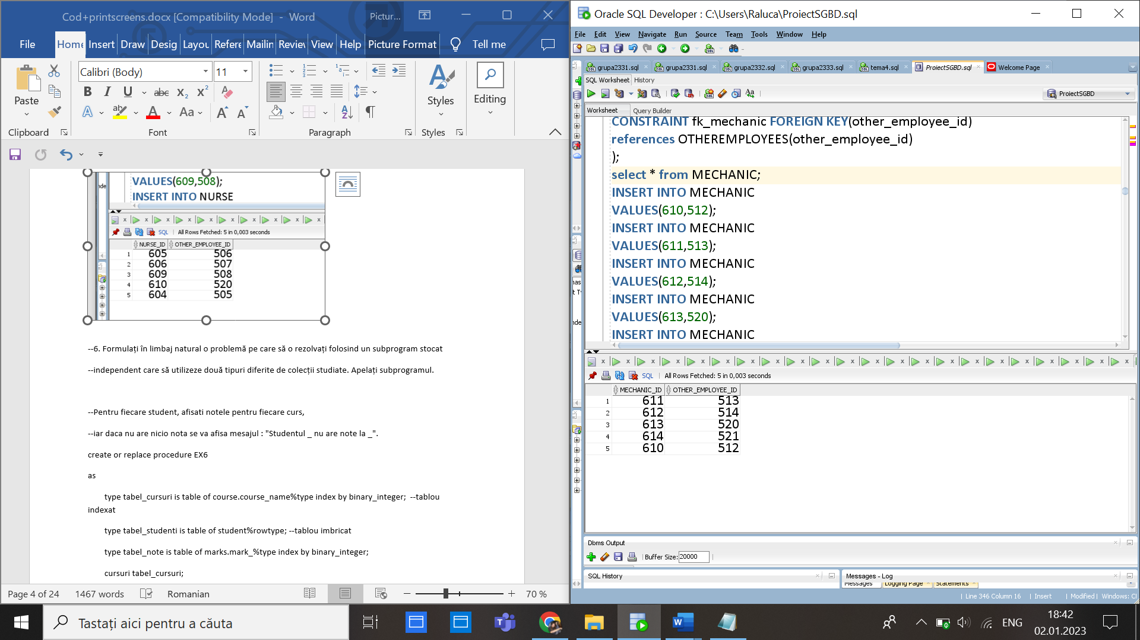

create table GUARDIAN

(

guardian_id NUMBER(10) constraint PKEY_GUARDIAN PRIMARY KEY,

other_employee_id NUMBER(10),

CONSTRAINT fk_guardian FOREIGN KEY(other_employee_id)

references OTHEREMPLOYEES(other_employee_id)

);

select * from GUARDIAN;

INSERT INTO GUARDIAN

VALUES(613,509);

INSERT INTO GUARDIAN

VALUES(610,510);

INSERT INTO GUARDIAN

VALUES(614,523);

INSERT INTO GUARDIAN

VALUES(615,524);

INSERT INTO GUARDIAN

VALUES(616,525);

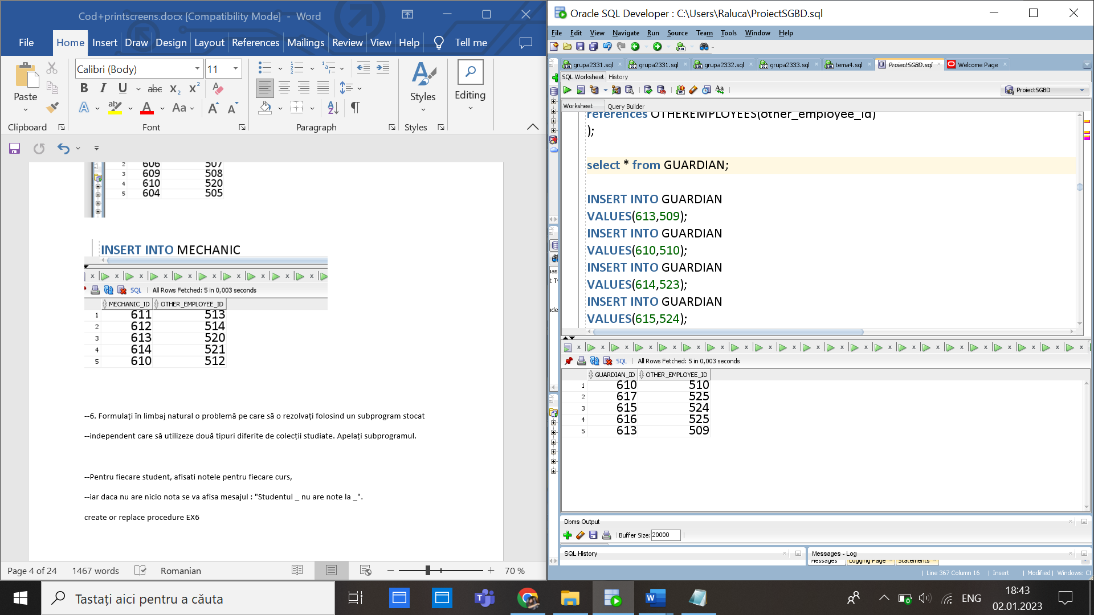

CREATE TABLE TEACHERS

(

teacher_id NUMBER(11) CONSTRAINT PKEY_TEACHER PRIMARY KEY,

employee_id NUMBER(10),

CONSTRAINT fk_teacher_employee FOREIGN KEY(employee_id)

references EMPLOYEE(employee_id)

);

select * from TEACHERS;

INSERT INTO TEACHERS

VALUES(61,31);

INSERT INTO TEACHERS

VALUES(62,32);

INSERT INTO TEACHERS

VALUES(63,33);

INSERT INTO TEACHERS

VALUES(64,34);

INSERT INTO TEACHERS

VALUES(65,35);

INSERT INTO TEACHERS

VALUES(66,36);

INSERT INTO TEACHERS

VALUES(67,37);

INSERT INTO TEACHERS

VALUES(68,38);

INSERT INTO TEACHERS

VALUES(69,39);

INSERT INTO TEACHERS

VALUES(70,40);

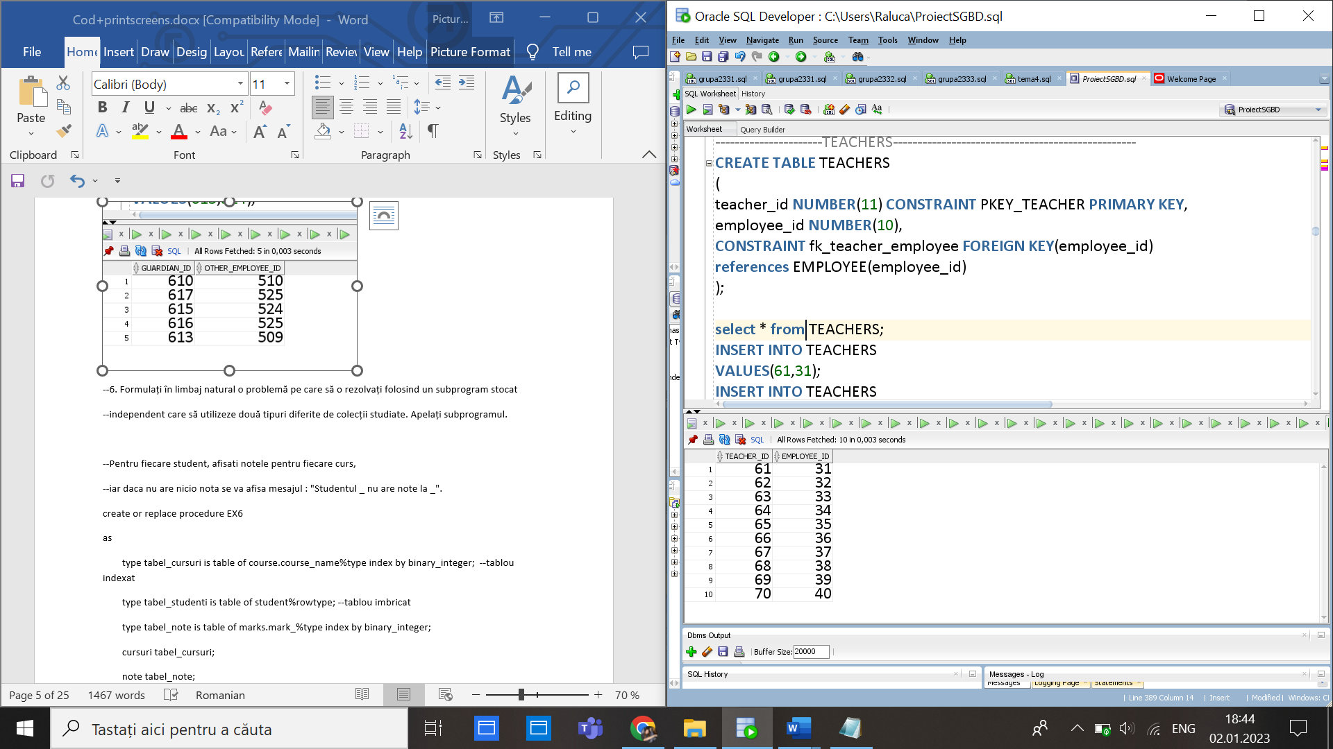

CREATE TABLE CLASSROOM

(

classroom_id NUMBER(10) CONSTRAINT PKEY_CLASSROOM PRIMARY KEY,

capacityy NUMBER(3) CONSTRAINT capacitate_sala NOT NULL,

classroom_type VARCHAR(25) CONSTRAINT tip_sala NOT NULL,

facilitati VARCHAR(255) CONSTRAINT facilitati_sala NOT NULL

);

select * from CLASSROOM;

INSERT INTO CLASSROOM

VALUES(80,30,'laborator','ustensile, videoproiector, whiteboard');

INSERT INTO CLASSROOM

VALUES(81,25,'laborator','videoproiector');

INSERT INTO CLASSROOM

VALUES(82,60,'amfiteatru','videoproiector, whiteboard');

INSERT INTO CLASSROOM

VALUES(83,30,'sala de clasa','whiteboard');

INSERT INTO CLASSROOM

VALUES(84,90,'sala de festivitati','videoproiector, whiteboard');

INSERT INTO CLASSROOM

VALUES(85,30,'Laborator de chimie','ustensile, whiteboard');

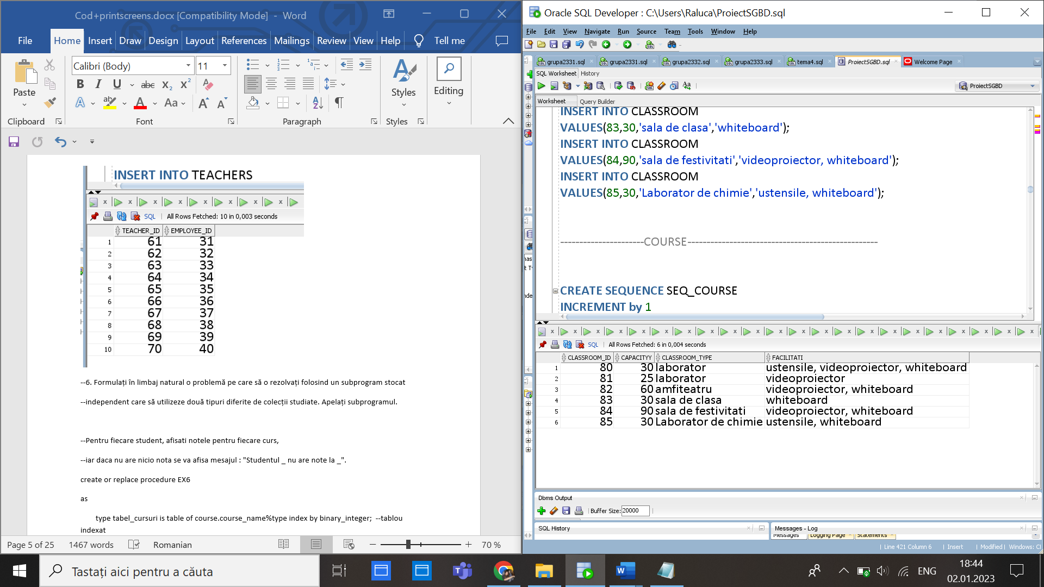

CREATE SEQUENCE SEQ_COURSE

INCREMENT by 1

START WITH 101

MAXVALUE 10000

NOCYCLE;

CREATE TABLE COURSE

(

course_id NUMBER(11) CONSTRAINT PKEY_COURSE PRIMARY KEY,

classroom_id NUMBER(10),

CONSTRAINT fk_course_classrooms FOREIGN KEY(classroom_id)

references CLASSROOM(classroom_id),

course_name VARCHAR(30) CONSTRAINT nume_materie NOT NULL,

course_desc VARCHAR(255) CONSTRAINT descriere_curs NOT NULL

);

select * from COURSE;

INSERT INTO COURSE

VALUES(SEQ_COURSE.NEXTVAL,83,'Matematica','Algebra');

INSERT INTO COURSE

VALUES(SEQ_COURSE.NEXTVAL,83,'Limba si literatura romana','Gramatica');

INSERT INTO COURSE

VALUES(SEQ_COURSE.NEXTVAL,82,'Engleza','Gramatica si Informal/Formal Letters');

INSERT INTO COURSE

VALUES(SEQ_COURSE.NEXTVAL,85,'Chimie','Chimie organica si anorganica');

INSERT INTO COURSE

VALUES(SEQ_COURSE.NEXTVAL,84,'Biologie','Chimie organica si anorganica');

INSERT INTO COURSE

VALUES(SEQ_COURSE.NEXTVAL,80,'Istorie','Istoria Romaniei');

select * from course;

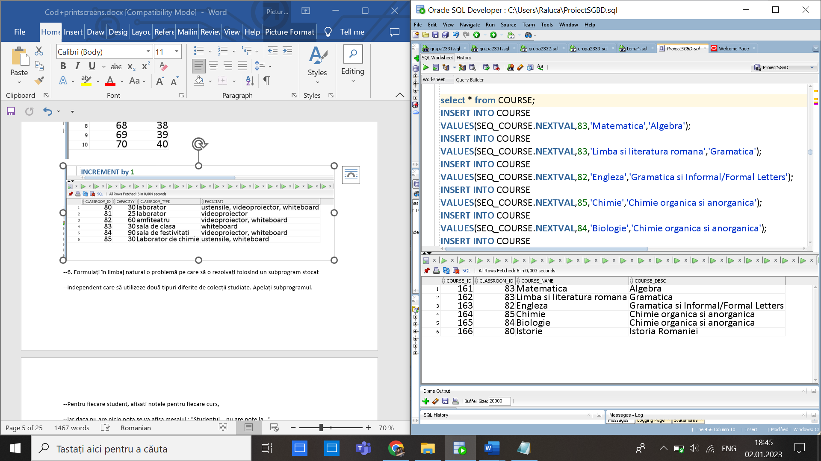

CREATE TABLE MARKS

(

mark_id NUMBER(10) CONSTRAINT PKEY_MARK PRIMARY KEY,

date_ DATE CONSTRAINT data_obtinere_nota NOT NULL,

mark_ NUMBER(2) CONSTRAINT nota_materie NOT NULL

);

select * from MARKS;

INSERT INTO MARKS

VALUES (111,TO_DATE('02-08-2021','DD-MM-YYYY'), 10);

INSERT INTO MARKS

VALUES (112,TO_DATE('02-09-2021','DD-MM-YYYY'), 9);

INSERT INTO MARKS

VALUES (113,TO_DATE('12-11-2021','DD-MM-YYYY'), 7);

INSERT INTO MARKS

VALUES (114,TO_DATE('02-07-2021','DD-MM-YYYY'), 9);

INSERT INTO MARKS

VALUES (115,TO_DATE('23-09-2021','DD-MM-YYYY'), 10);

INSERT INTO MARKS

VALUES (116,TO_DATE('12-06-2021','DD-MM-YYYY'), 8);

INSERT INTO MARKS

VALUES (117,TO_DATE('14-11-2021','DD-MM-YYYY'), 5);

INSERT INTO MARKS

VALUES (118,TO_DATE('17-06-2021','DD-MM-YYYY'), 10);

INSERT INTO MARKS

VALUES (119,TO_DATE('18-01-2021','DD-MM-YYYY'), 5);

INSERT INTO MARKS

VALUES (120,TO_DATE('19-02-2021','DD-MM-YYYY'), 4);

INSERT INTO MARKS

VALUES (120,TO_DATE('19-02-2021','DD-MM-YYYY'), 4);

INSERT INTO MARKS

VALUES (121,TO_DATE('19-02-2021','DD-MM-YYYY'), 8);

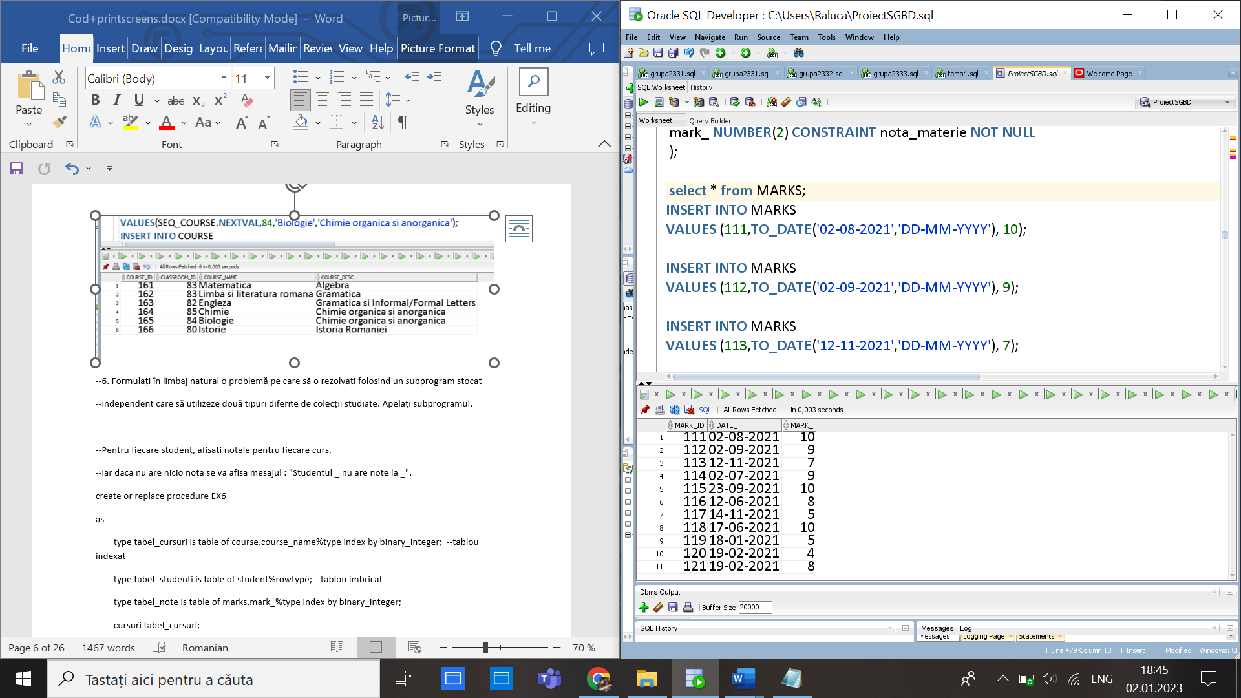

CREATE TABLE PARENTS

(

parent_id NUMBER(10) CONSTRAINT PKEY_PARENT PRIMARY KEY,

address_id NUMBER(10),

first_name VARCHAR(40) CONSTRAINT prenume_parinte NOT NULL,

last_name VARCHAR(40) CONSTRAINT nume_parinte NOT NULL,

sex VARCHAR(10) CONSTRAINT sex_parinte NOT NULL,

email_ VARCHAR(40) UNIQUE,

phone_number NUMBER(10) UNIQUE,

CONSTRAINT fk_address_parent FOREIGN KEY(address_id)

references ADDRESSES(address_id)

);

select * from PARENTS;

INSERT INTO PARENTS

VALUES(131,3,'Gaias','Natalia','feminin','gaias_natalia@yahoo.com',0777777777);

INSERT INTO PARENTS

VALUES(132,3,'Gaias','Marian','masculin','gaias_marian@yahoo.com',0788888888);

INSERT INTO PARENTS

VALUES(133,1,'Ionescu','Georgiana','feminin','ionescu_georgiana@yahoo.com',0799999999);

INSERT INTO PARENTS

VALUES(137,1,'Ionescu','Alex','masculin','ionescu_alex@yahoo.com',0799922999);

INSERT INTO PARENTS

VALUES(134,6,'Iancu','Diana','feminin','iancu_diana@yahoo.com',0777774444);

INSERT INTO PARENTS

VALUES(138,6,'Iancu','Serban','masculin','iancu_serbanyahoo.com',0771177777);

INSERT INTO PARENTS

VALUES(135,4,'Popescu','Elena','feminin','popescu_elena@yahoo.com',0709997777);

INSERT INTO PARENTS

VALUES(136,4,'Popescu','Andrei','masculin','popescu_andrei@yahoo.com',0711117777);

INSERT INTO PARENTS

VALUES(140,4,'Anghel','Sorina','feminin','anghel_sorina@yahoo.com',0709948777);

INSERT INTO PARENTS

VALUES(139,9,'Anghel','Andrei','masculin','anghel_andrei@yahoo.com',07432117777);

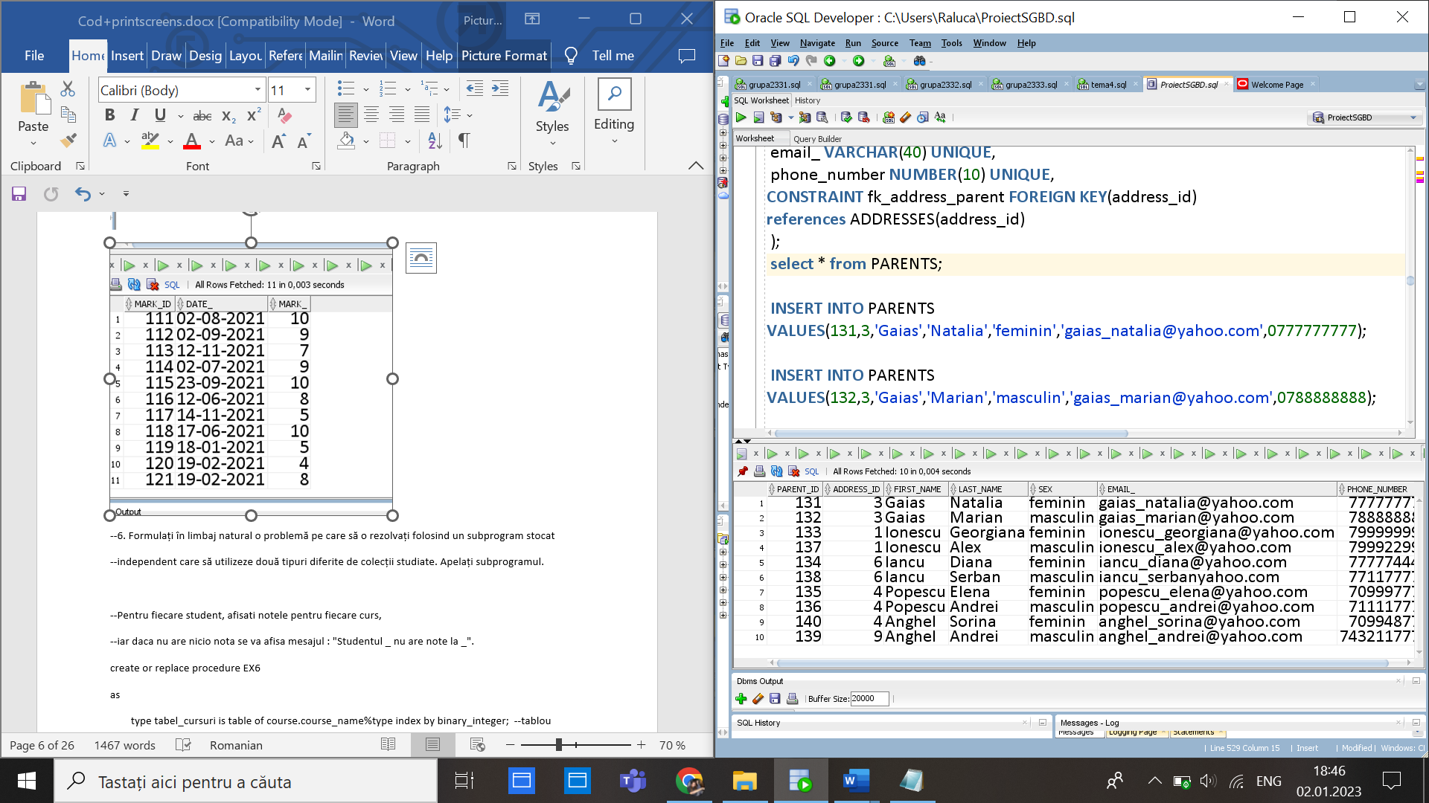

create table MAMA

(

mama_id NUMBER(10) constraint PKEY_MAMA PRIMARY KEY,

parent_id NUMBER(10),

CONSTRAINT fk_mama_parent FOREIGN KEY(parent_id)

references PARENTS(parent_id)

);

select * from PARENTS;

select * from MAMA;

insert into MAMA

values(141,131);

insert into MAMA

values(142,133);

insert into MAMA

values(143,134);

insert into MAMA

values(144,135);

insert into MAMA

values(145,137);

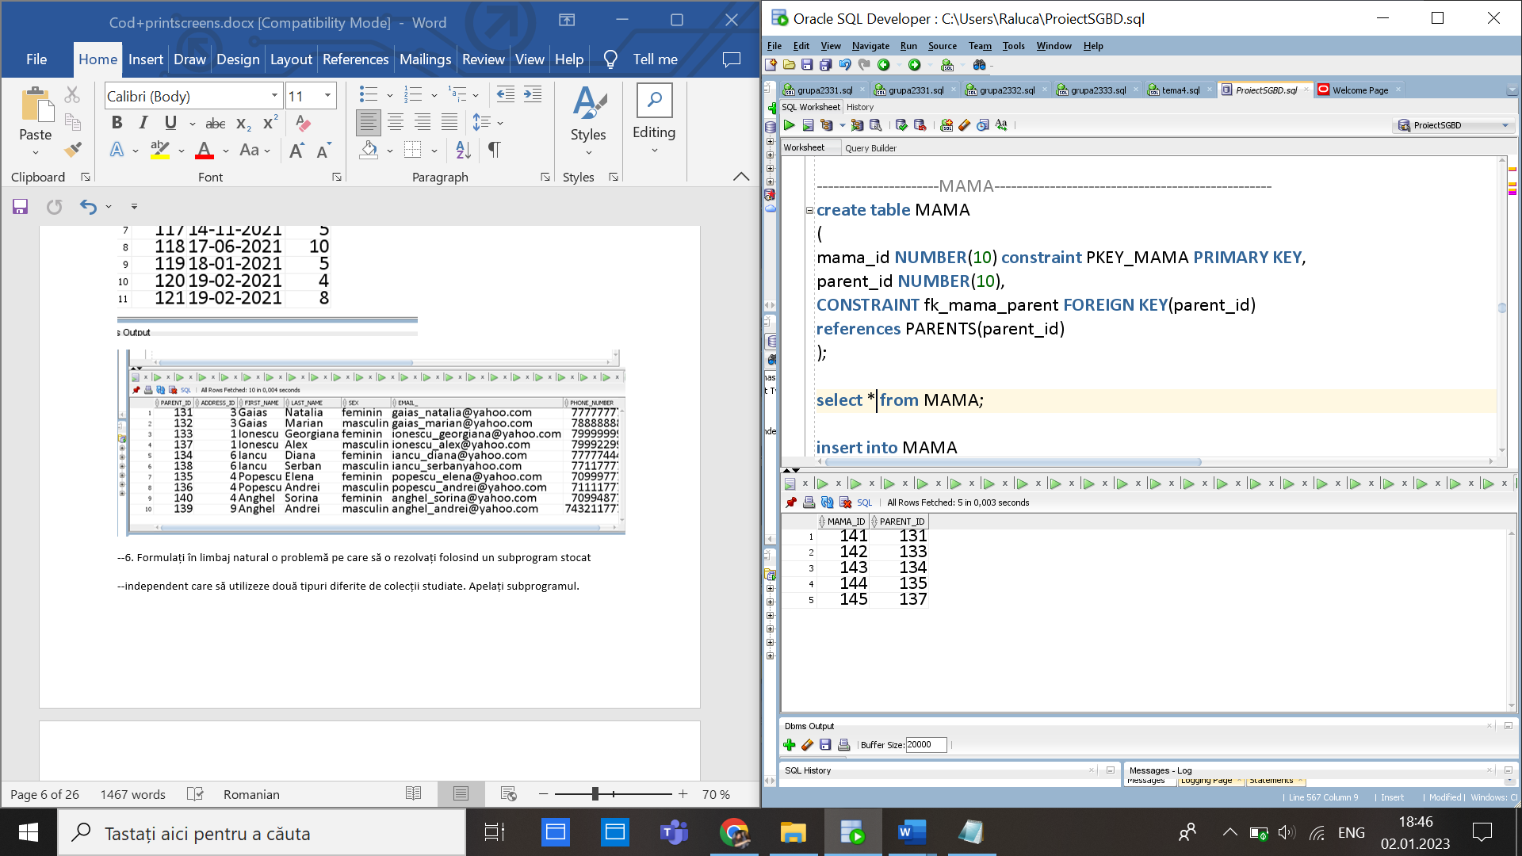

create table TATA

(

tata_id NUMBER(10) constraint PKEY_TATA PRIMARY KEY,

parent_id NUMBER(10),

CONSTRAINT fk_tata_parent FOREIGN KEY(parent_id)

references PARENTS(parent_id)

);

select * from TATA;

insert into TATA

values(151,132);

insert into TATA

values(152,137);

insert into TATA

values(153,138);

insert into TATA

values(154,136);

insert into TATA

values(155,139);

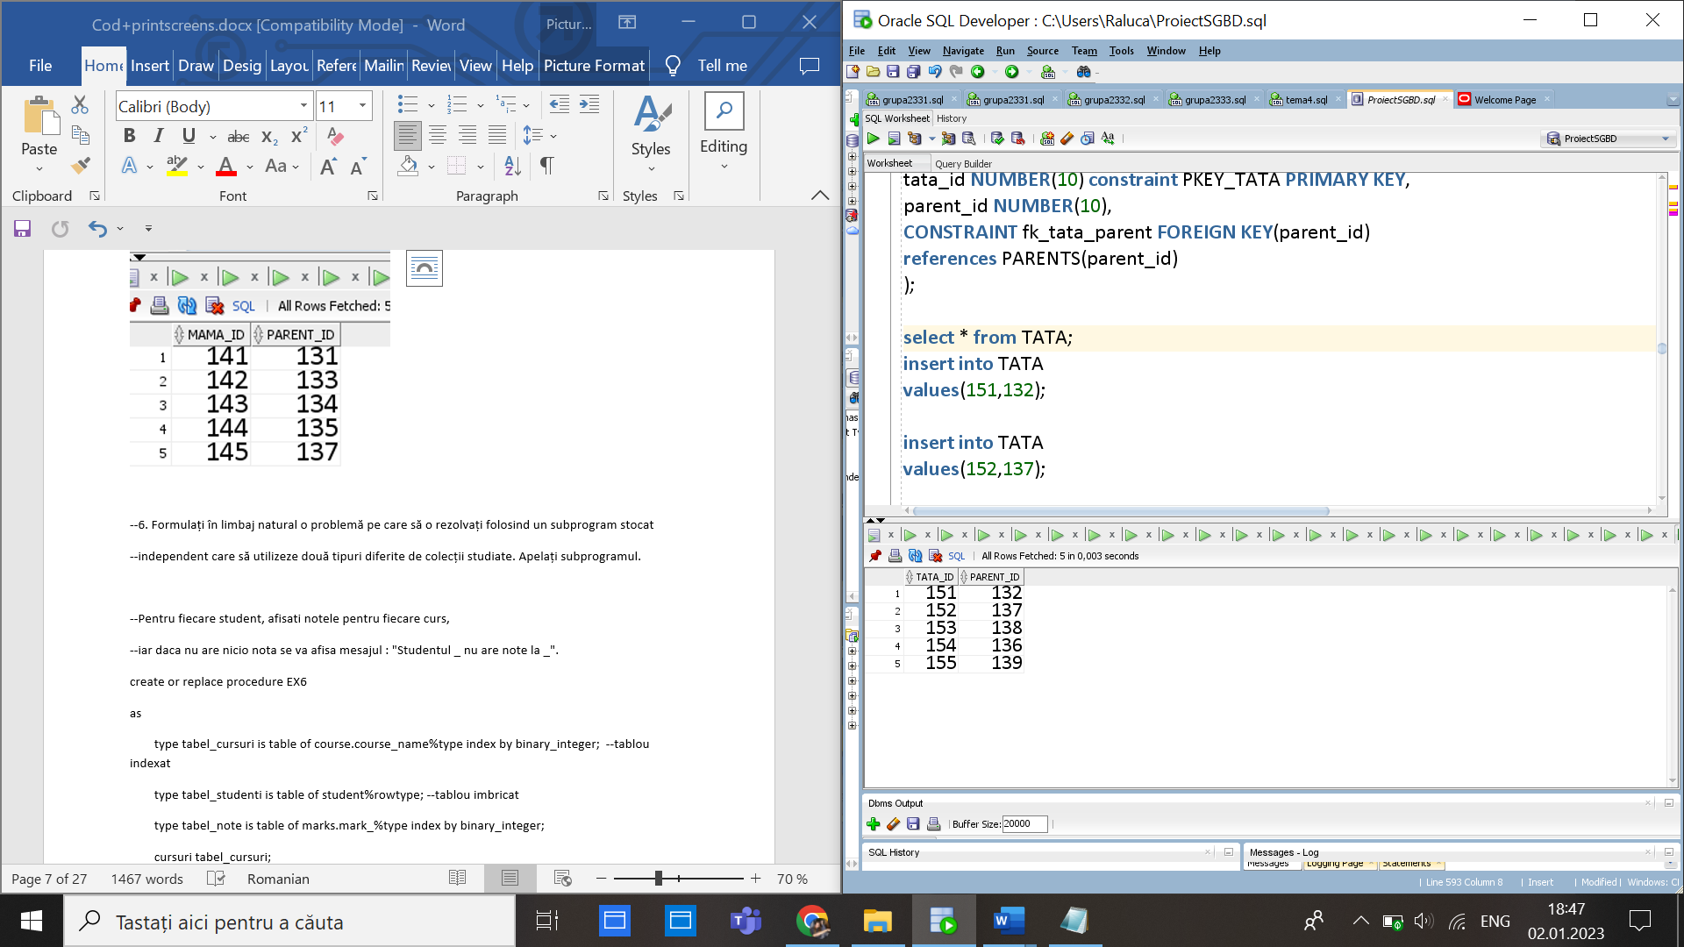

CREATE TABLE CATALOG

(student_id NUMBER(10) CONSTRAINT pk_st_catalog REFERENCES STUDENT(student_id),

mark_id NUMBER(10) CONSTRAINT pk_ma_catalog REFERENCES MARKS(mark_id),

course_id NUMBER(11) CONSTRAINT pk_co_catalog REFERENCES COURSE(course_id),

CONSTRAINT pk_catalog primary key(student_id,mark_id,course_id)

);

insert into CATALOG

values(21,111,101);

insert into CATALOG

values(22,112,102);

insert into CATALOG

values(23,113,103);

select * from course;

insert into CATALOG

values(24,114,104);

insert into CATALOG

values(24,115,10);

insert into CATALOG

values(25,115,105);

insert into CATALOG

values(25,116,106);

insert into CATALOG

values(24,121,106);

insert into CATALOG

values(23,118,102);

insert into CATALOG

values(22,119,103);

insert into CATALOG

values(21,120,101);

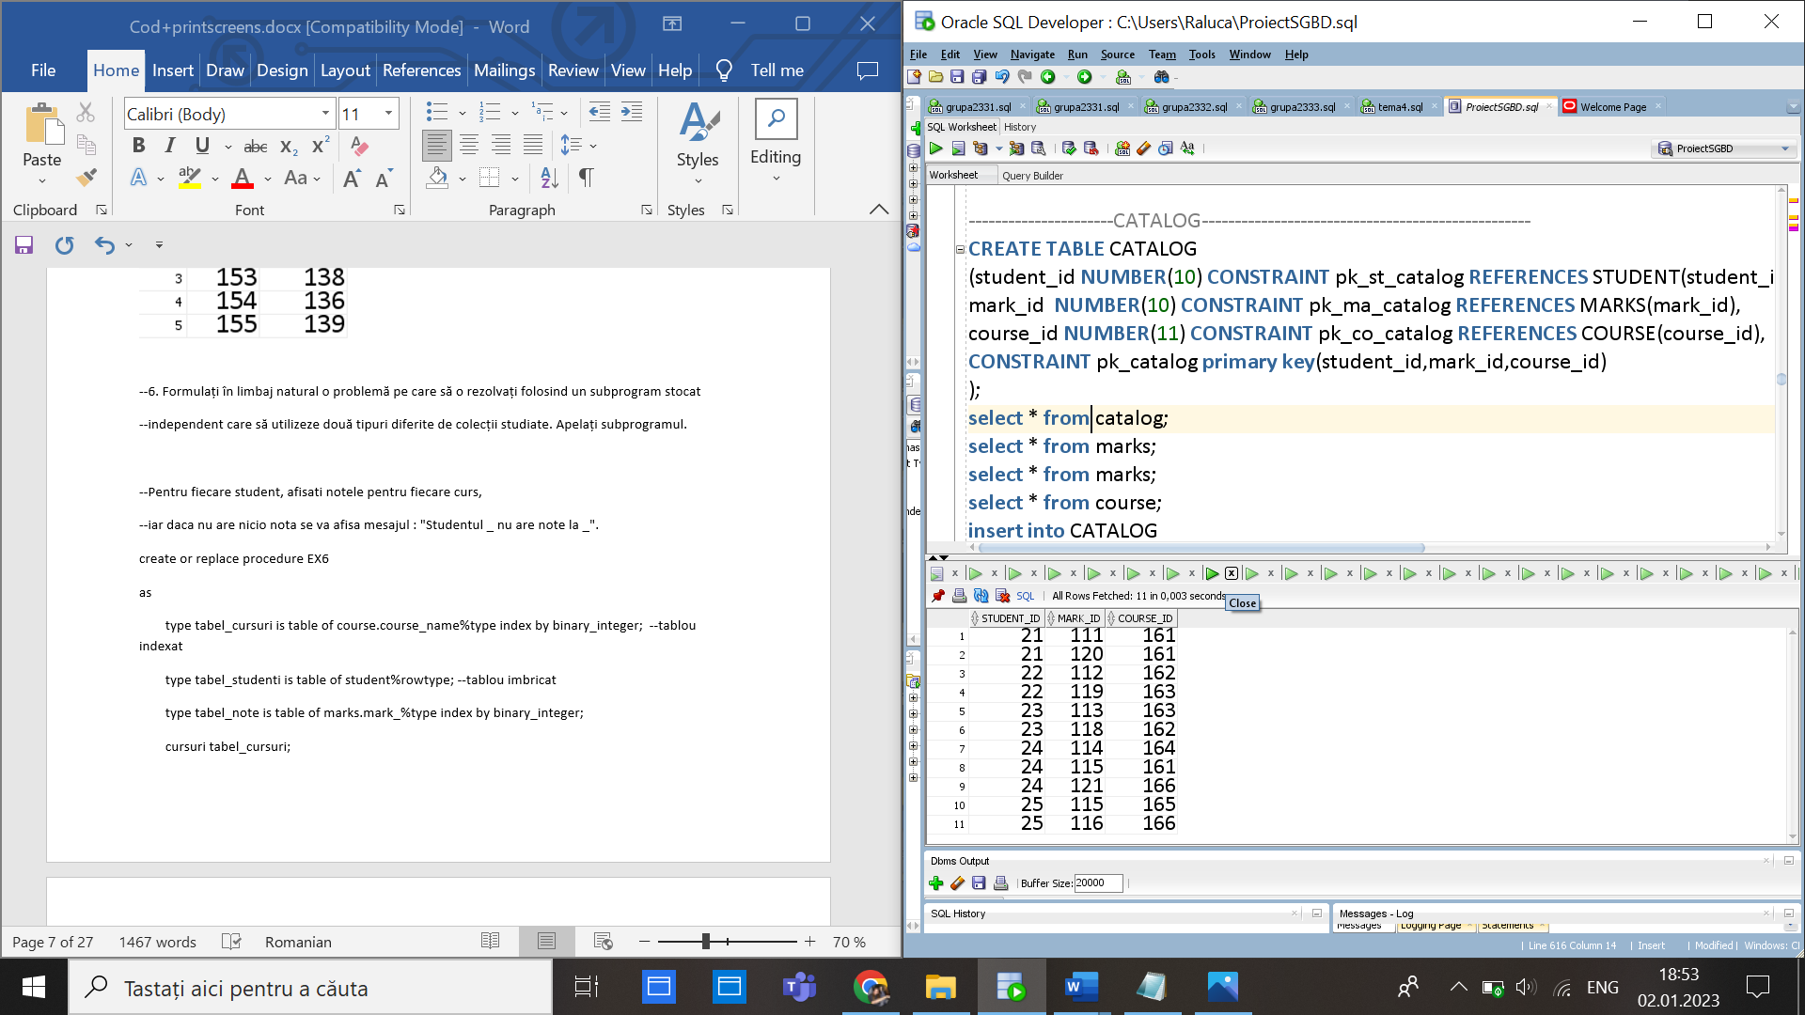

CREATE TABLE ELEVI_PARINTI

(student_id NUMBER(10) CONSTRAINT pk_st_e_p REFERENCES STUDENT(student_id),

parent_id NUMBER(10) CONSTRAINT pk_pa_e_p REFERENCES PARENTS(parent_id),

number_of_family_members NUMBER(10) CONSTRAINT nb_of_members NOT NULL,

CONSTRAINT pk_elevi_parinti primary key(student_id,parent_id)

);

insert into ELEVI_PARINTI

values(25,131,3);

insert into ELEVI_PARINTI

values(25,132,3);

insert into ELEVI_PARINTI

values(21,137,4);

insert into ELEVI_PARINTI

values(21,133,4);

insert into ELEVI_PARINTI

values(22,137,4);

insert into ELEVI_PARINTI

values(22,133,4);

insert into ELEVI_PARINTI

values(23,135,3);

insert into ELEVI_PARINTI

values(23,136,3);

insert into ELEVI_PARINTI

values(24,138,3);

insert into ELEVI_PARINTI

values(24,134,3);

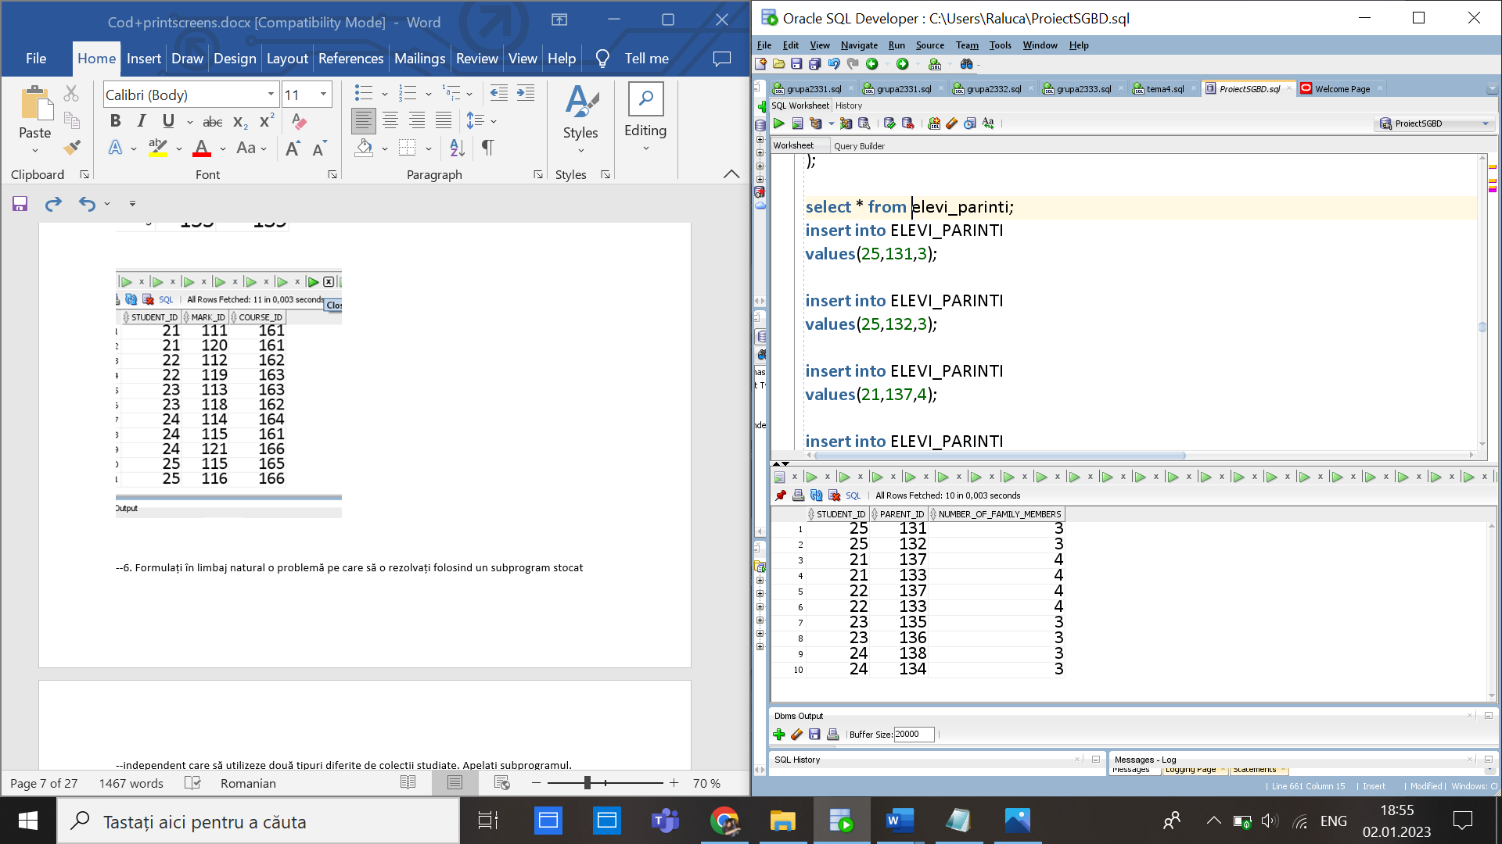

CREATE TABLE PREDA

(teacher_id NUMBER(10) CONSTRAINT pk_p_t REFERENCES TEACHERS(teacher_id),

course_id NUMBER(10) CONSTRAINT pk_p_c REFERENCES COURSE(course_id),

CONSTRAINT pk_preda primary key(teacher_id,course_id)

);

select * from PREDA;

insert into PREDA

values(61,101);

insert into PREDA

values(62,102);

insert into PREDA

values(63,103);

insert into PREDA

values(64,104);

insert into PREDA

values(65,105);

insert into PREDA

values(66,106);

insert into PREDA

values(67,101);

insert into PREDA

values(68,102);

insert into PREDA

values(69,103);

insert into PREDA

values(70,101);

insert into PREDA

values(70,102);

insert into PREDA

values(70,103);

insert into PREDA

values(70,104);

insert into PREDA

values(70,105);

insert into PREDA

values(70,106);

insert into PREDA

values(68,101);

insert into PREDA

values(68,103);

insert into PREDA

values(68,104);

insert into PREDA

values(68,105);

insert into PREDA

values(68,106);

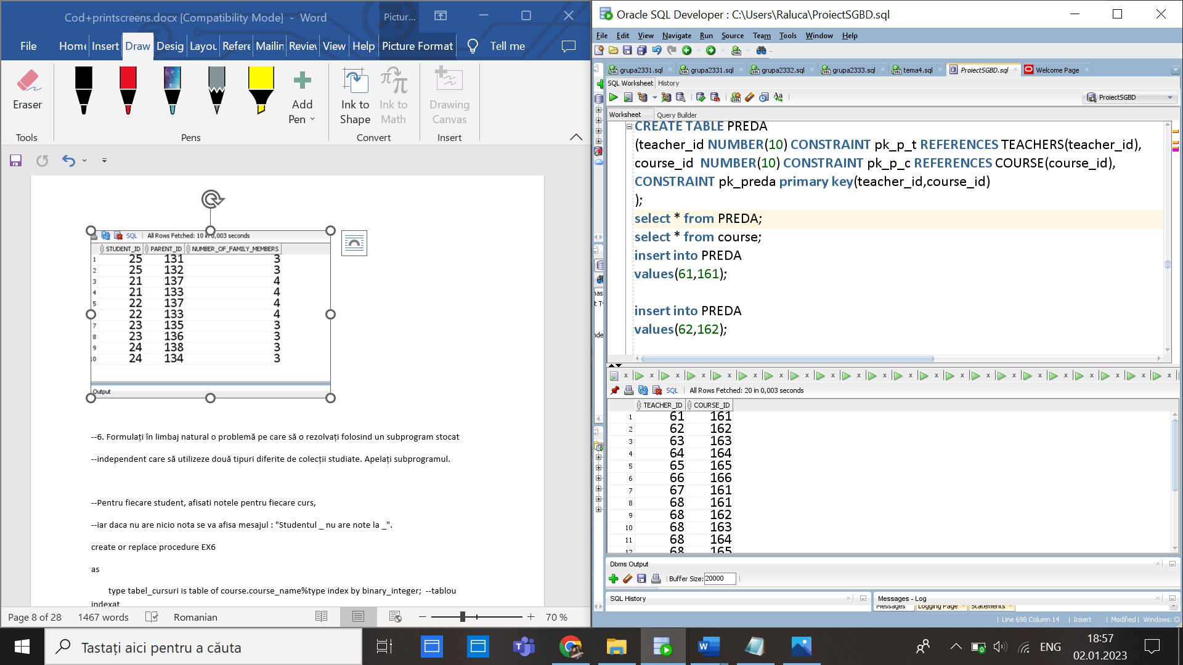

--6. Formulați în limbaj natural o problemă pe care să o rezolvați folosind un subprogram stocat

--independent care să utilizeze două tipuri diferite de colecții studiate. Apelați subprogramul.

--Pentru fiecare student, afisati notele pentru fiecare curs,

--iar daca nu are nicio nota se va afisa mesajul : "Studentul _ nu are note la _".

create or replace procedure EX6

as

type tabel_cursuri is table of course.course_name%type index by binary_integer; --tablou indexat

type tabel_studenti is table of student%rowtype; --tablou imbricat

type tabel_note is table of marks.mark_%type index by binary_integer;

cursuri tabel_cursuri;

note tabel_note;

studenti tabel_studenti:=tabel_studenti();

numar NUMBER:=0;

-- select * from user_tables;

-- select * from course;

BEGIN

select course_name

bulk collect into cursuri

from course ;

select *

bulk collect into studenti

from student;

FOR i IN studenti.FIRST..studenti.LAST LOOP

numar:=0;

for j in cursuri.first..cursuri.last loop

select count(*) into numar

from course co ,catalog c, student s,marks m

where s.student_id=c.student_id and m.mark_id=c.mark_id

and co.course_id=c.course_id

and s.student_id=studenti(i).student_id and co.course_name=cursuri(j);

if numar=0 then DBMS_OUTPUT.PUT_LINE('Studentul: '||studenti(i).first_name || ' ' || studenti(i).last_name|| ' nu are note la '||cursuri(j));

end if;

if numar>0 then

DBMS_OUTPUT.PUT('Studentul: '||studenti(i).first_name || ' ' || studenti(i).last_name|| ' are la '||cursuri(j) || ' notele: ');

select m.mark_ bulk collect into note

from course co ,catalog c, student s,marks m

where s.student_id=c.student_id and m.mark_id=c.mark_id

and co.course_id=c.course_id

and s.student_id=studenti(i).student_id and co.course_name=cursuri(j);

for k in note.first..note.last loop

dbms_output.put(note(k)|| ' ');

end loop;

DBMS_OUTPUT.NEW_LINE();

end if;

end loop;

DBMS_OUTPUT.PUT_LINE('--------------------------');

END LOOP;

end ;

/

BEGIN

Ex6;

END;

/

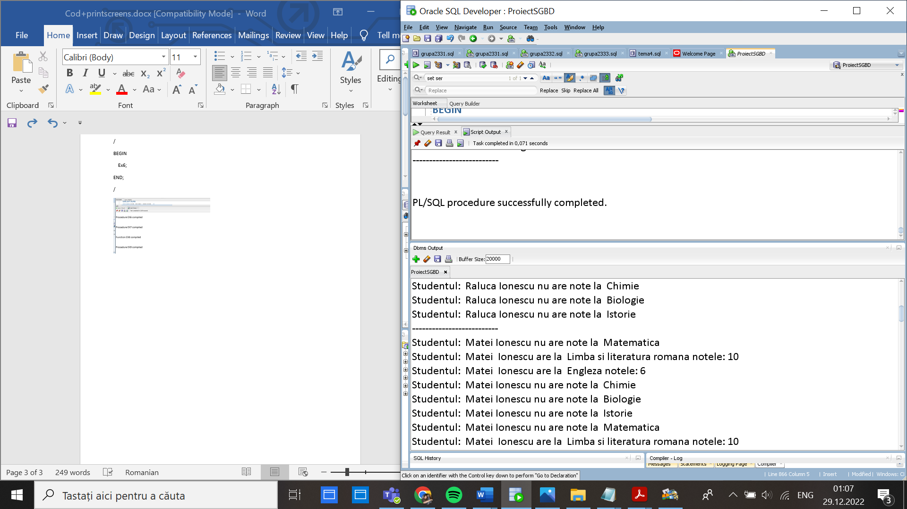

--7. Formulați în limbaj natural o problemă pe care să o rezolvați folosind un subprogram stocat

--independent care să utilizeze 2 tipuri diferite de cursoare studiate, unul dintre acestea fiind cursor

--parametrizat. Apelați subprogramul.

--pentru scolile cu o descriere data, sa se mareasca

--salariile angajatilor care nu sunt profesori cu 200

create or replace procedure EX7

as

--cursor parametrizat

Cursor scoli(descc school.school_desc%type) is

select school_id

from school

where school_desc=descc;

CURSOR c IS

select employee_id

from otheremployees;

id_scoala school.school_id%type;

id_ employee.employee_id%type;

begin

open scoli('Clase speciale de matematica si informatica');

loop

fetch scoli into id_scoala;

exit when scoli%notfound;

open c;

LOOP

fetch c into id_;

exit when c%notfound;

UPDATE employee

SET salary = salary +200

where employee_id=id_ and school_id=id_scoala;

END LOOP;

close c;

end loop;

close scoli;

end;

/

BEGIN

EX7;

END;

/

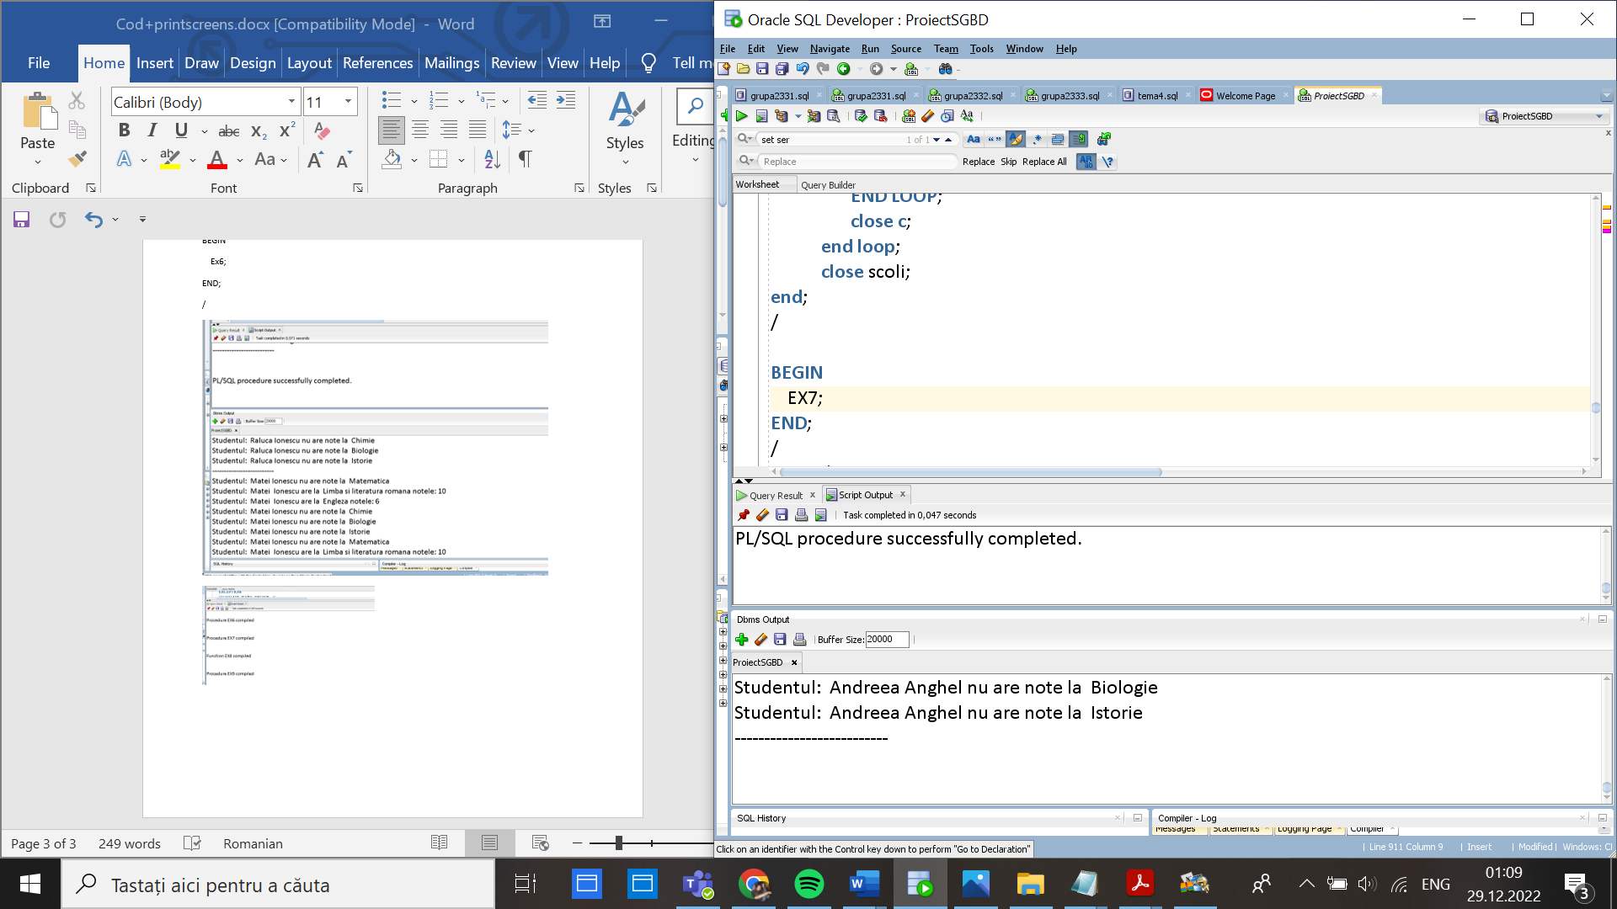

--8. Formulați în limbaj natural o problemă pe care să o rezolvați folosind un subprogram stocat

--independent de tip funcție care să utilizeze într-o singură comandă SQL 3 dintre tabelele definite.

--Definiți minim 2 excepții. Apelați subprogramul astfel încât să evidențiați toate cazurile tratate.

select * from teachers t, preda p, course c , classroom cl

where p.teacher_id=t.teacher_id and p.course_id=c.course_id and cl.classroom_type like '%aborator%'

and c.classroom_id=cl.classroom_id;

order by t.teacher_id;

select * from employee;

select * from user_tables;

select * from teachers;

select * from teachers t, employee e where e.employee_id=t.employee_id;

select * from classroom;

update employee

set last_name='Alina'

where employee_id=37 or employee_id=36;

--Pentru un profesor al carui prennume este dat, sa se afiseze numarul

--de cursuri pe care desfasoara intr-o sala care este laborator.

--profesori mai multi cu acelasi prenume->exceptie

--nu exista cursuri->exceptie

create or replace function ex8(nume employee.last_name%type) return NUMBER is rezultat number;

numar NUMBER:=0;

id_prof teachers.teacher_id%type;

NO_TEACHER exception;

MORE_THAN_ONE_TEACHER exception;

begin

select count(t.teacher_id) into numar

from employee e , teachers t

where e.last_name=nume and e.employee_id=t.employee_id;

if numar=0 then

raise NO_TEACHER;

end if;

if numar>1 then

raise MORE_THAN_ONE_TEACHER;

end if;

select t.teacher_id into id_prof

from employee e , teachers t

where e.last_name=nume and e.employee_id=t.employee_id;

select count(*) into rezultat

from preda p, course c, classroom cl

where lower(cl.classroom_type) like '%laborator%'

and p.teacher_id=id_prof and c.course_id=p.course_id

and c.classroom_id=cl.classroom_id;

return rezultat;

EXCEPTION

WHEN NO_TEACHER then

DBMS_OUTPUT.PUT_LINE('Nu exista acest profesor!');

return -1;

WHEN MORE_THAN_ONE_TEACHER THEN

DBMS_OUTPUT.PUT_LINE('Mai multi profesori cu acest nume!');

return -1;

end;

/

DECLARE

numar_corect NUMBER;

BEGIN

numar_corect := Ex8('Bianca'); --are 2 cursuri

DBMS_OUTPUT.PUT_LINE('Profesorul cu prenumele Bianca tine ' || numar_corect||' cursuri in laboratoare.' );

END;

/

declare

numar_nu_exista NUMBER;

begin

DBMS_OUTPUT.PUT_LINE('Exceptia NO_TEACHERS');

numar_nu_exista :=ex8('xxxxx'); --nu exista

end;

/

declare

numar_mai_multi NUMBER;

begin

DBMS_OUTPUT.PUT_LINE('Exceptia MORE_THAN_ONE_TEACHER');

numar_mai_multi := Ex8('Alina');--mai multi cu numele asta

end;

/

declare

numar_zero NUMBER;

begin

numar_zero := Ex8('Alexandru'); -- nu are astfel de cursuri

DBMS_OUTPUT.PUT_LINE('Profesor Alexandru tine '|| numar_zero ||' cursuri in laboratoare(fara exceptie) ');

end;

/

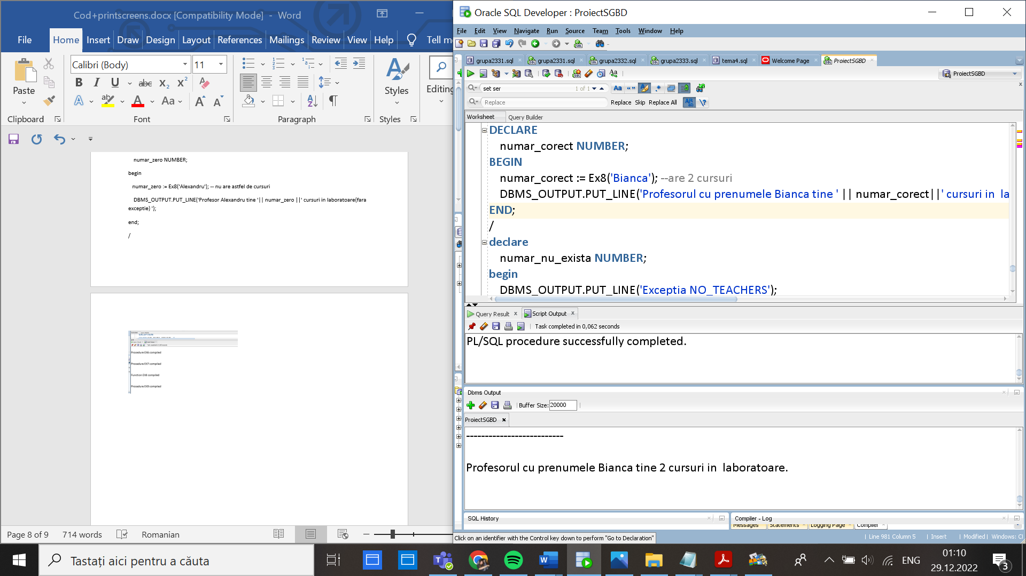

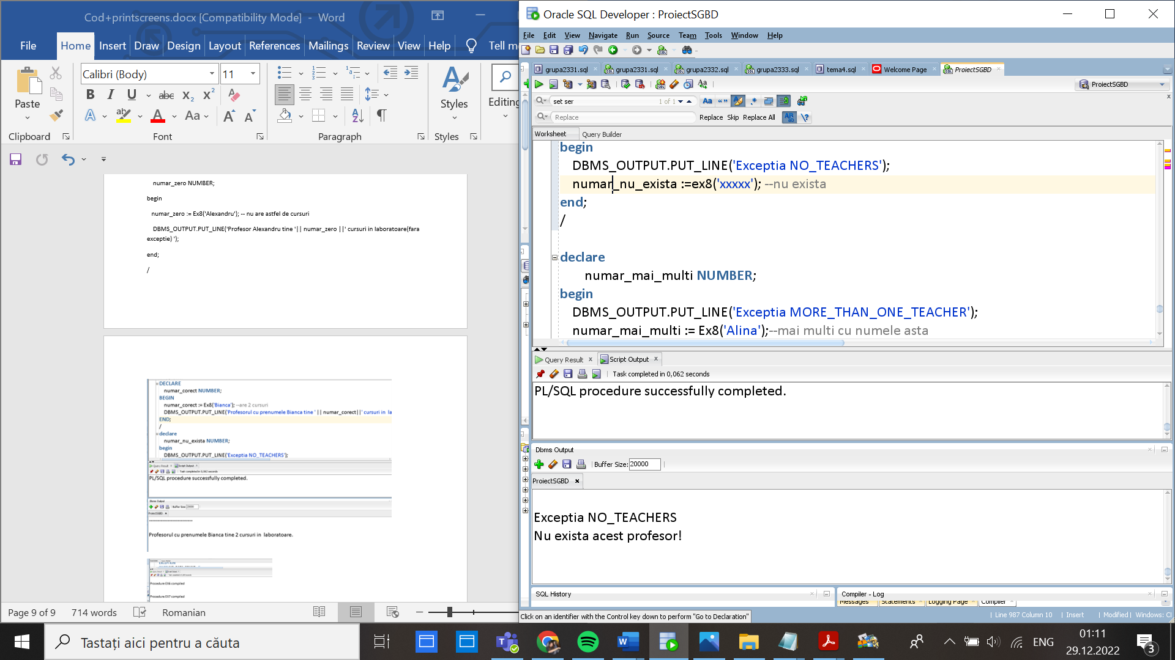

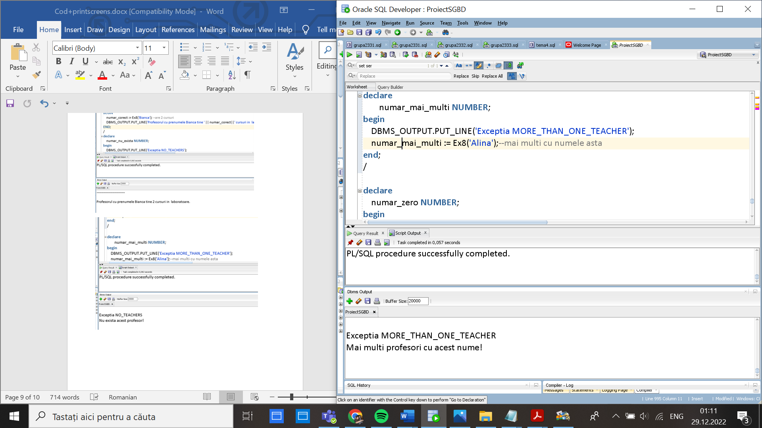

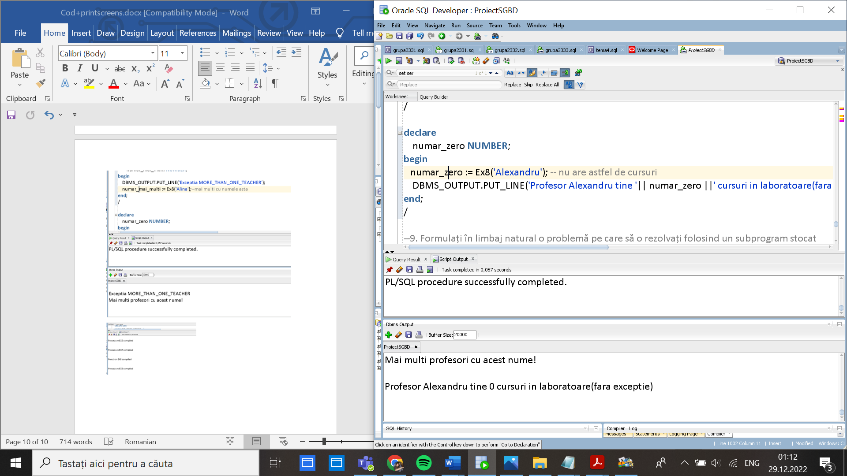

--9. Formulați în limbaj natural o problemă pe care să o rezolvați folosind un subprogram stocat

--independent de tip procedură care să utilizeze într-o singură comandă SQL 5 dintre tabelele

--definite. Tratați toate excepțiile care pot apărea, incluzând excepțiile NO_DATA_FOUND și

--TOO_MANY_ROWS. Apelați subprogramul astfel încât să evidențiați toate cazurile tratate.

select s.last_name,co.course_name, max(m.mark_)

from student s, catalog ca, marks m, course co, classroom cl

where s.student_id=ca.student_id

and m.mark_id=ca.mark_id

and co.course_id=ca.course_id

and cl.classroom_id=co.classroom_id and cl.classroom_type like '%clasa'

group by s.last_name,co.course_name;

--sa se afiseze pentru un student al carui nume de familie este dat,

--nota cea mai mare la fiecare curs la care participa si care are loc intr-o sala de clasa,

--exceptii->mai multi copii cu acelasi nume

-- ->nu exista copilul/copilul nu are note inca/ copilul nu are note la un curs dintr-o sala de clasa

create or replace procedure ex9(nume student.last_name%type)

as

type t_cursuri is table of course.course_name%type index by binary_integer;

type t_note is table of marks.mark_%type index by binary_integer;

NO_DATA_FOUND_ exception;

NO_DATA_FOUND_2 exception;

TOO_MANY_ROWS_ exception;

cursuri t_cursuri;

note t_note;

nr number:=0;

prenume student.first_name%type;

begin

select count(*) into nr

from student

where last_name=nume;

if nr=0 then raise NO_DATA_FOUND_;

end if;

if nr>1 then raise TOO_MANY_ROWS_;

end if;

nr:=0;

select count(*) into nr

from student s, catalog ca, marks m, course co, classroom cl

where s.student_id=ca.student_id

and m.mark_id=ca.mark_id

and co.course_id=ca.course_id

and cl.classroom_id=co.classroom_id

and s.last_name=nume and cl.classroom_type like '%clasa';

if nr=0 then raise NO_DATA_FOUND_2;

end if;

select first_name into prenume

from student

where last_name=nume;

DBMS_OUTPUT.PUT_LINE('Notele elevului '|| prenume||' '||nume||': ');

select co.course_name, max(m.mark_)

bulk collect into cursuri, note

from student s, catalog ca, marks m, course co, classroom cl

where s.student_id=ca.student_id

and m.mark_id=ca.mark_id

and co.course_id=ca.course_id

and cl.classroom_id=co.classroom_id

and s.last_name=nume and cl.classroom_type like '%clasa'

group by co.course_name;

for i in cursuri.first..cursuri.last loop

DBMS_OUTPUT.PUT_LINE(' '||cursuri(i)|| ' : '|| note(i));

end loop;

EXCEPTION

WHEN NO_DATA_FOUND_ then

DBMS_OUTPUT.PUT_LINE('Nu exista studentul');

WHEN TOO_MANY_ROWS_ then

DBMS_OUTPUT.PUT_LINE('Mai multi elevi cu acest nume');

WHEN NO_DATA_FOUND_2 then

DBMS_OUTPUT.PUT_LINE('Student gasit, dar nu are note la un astfel de curs');

end;

/

select * from user_tables;

begin

ex9('Popescu'); --corect

end;

/

begin

ex9('xxx'); --nu exista

end;

/

begin

ex9('Ionescu'); -- mai multi cu acelasi nume

end;

/

begin

ex9('Gaias'); --gasit dar nu are note la un astfel de curs

end;

/

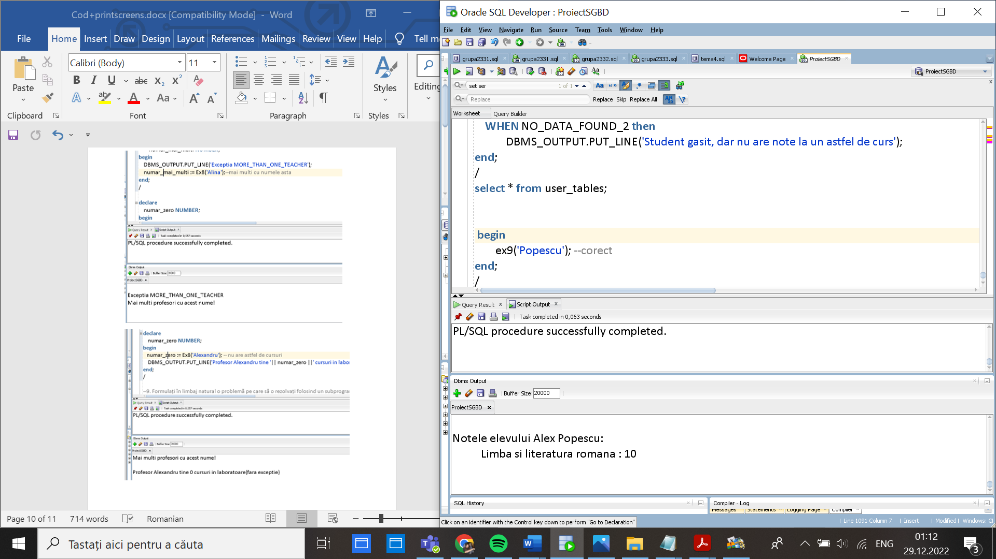

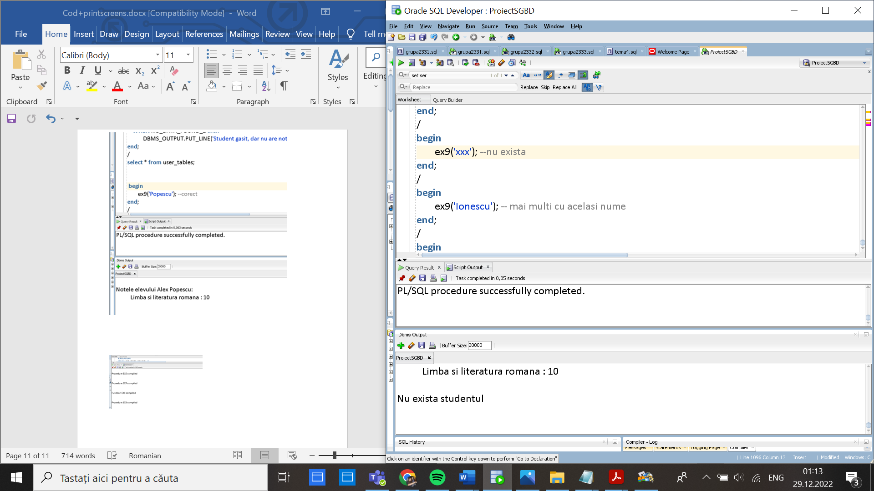

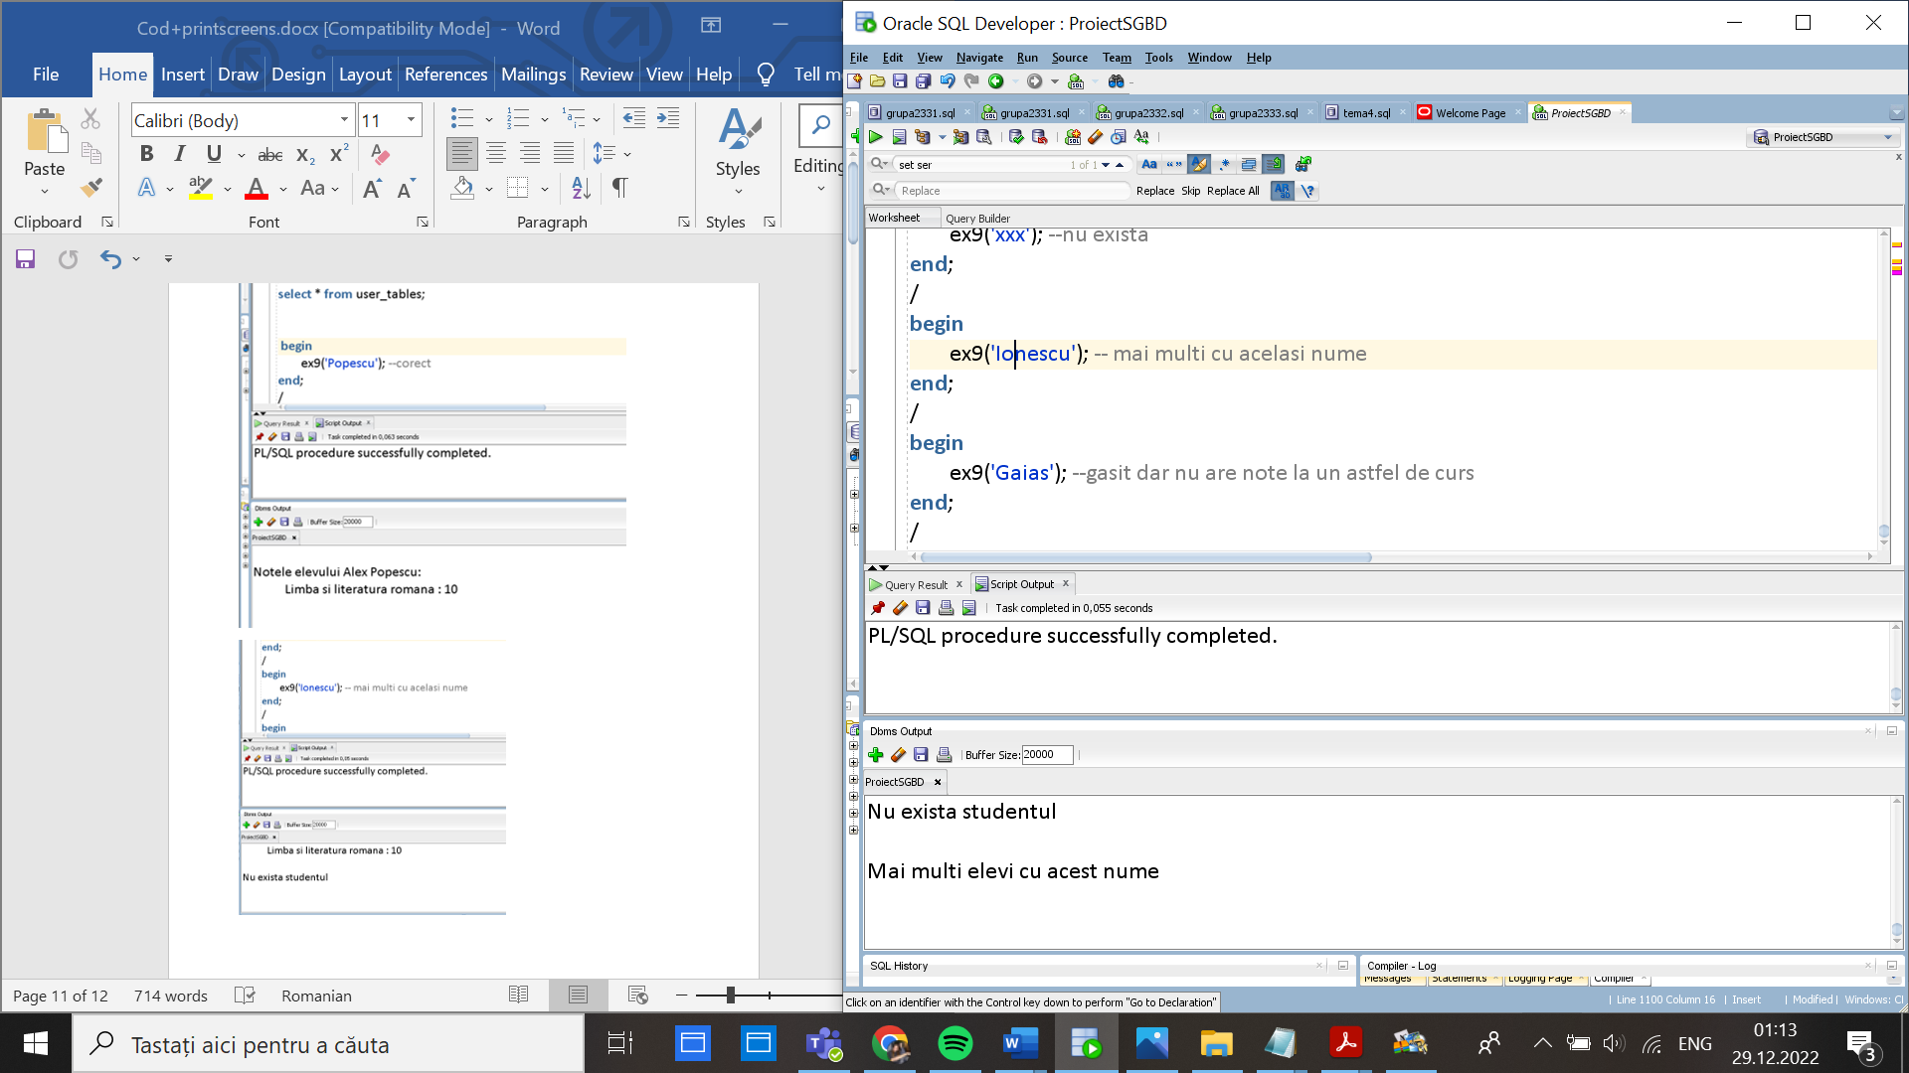

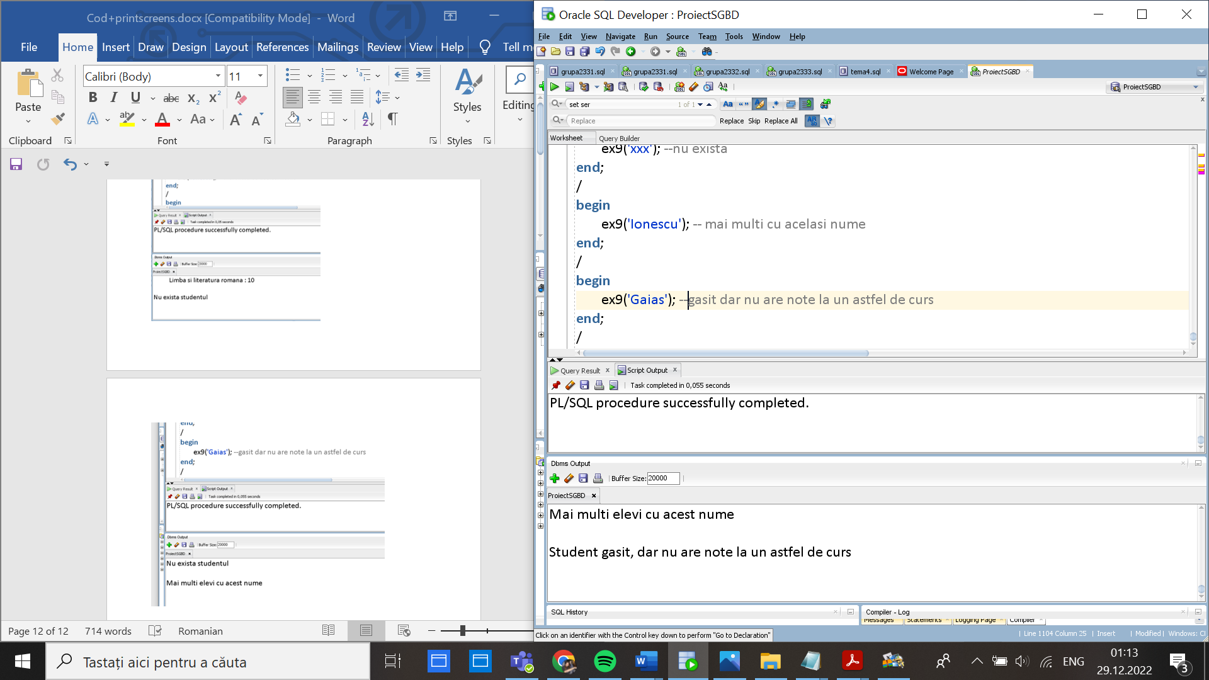

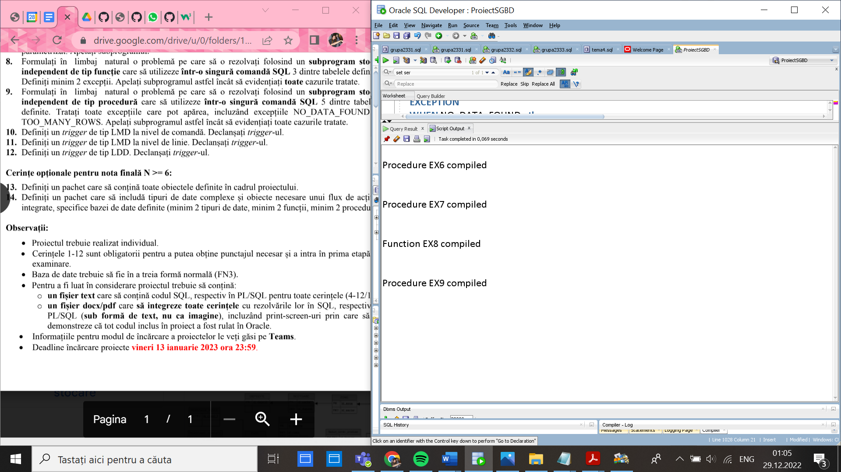

--10. Definiti un trigger de tip LMD la nivel de comandă. Declansati trigger-ul.

--trigger care nu permite adaugarea/schimbarea unei note in afara orele de cursuri( 8:00-16:00)

--sau a zilelor de cursuri(Sambata Duminica)

CREATE OR REPLACE TRIGGER trigger10

BEFORE INSERT OR DELETE OR UPDATE on marks

BEGIN

IF (TO_CHAR(SYSDATE,'D') = 6) or (TO_CHAR(SYSDATE,'D') = 7) or(TO_CHAR(SYSDATE,'HH24') NOT BETWEEN 8 AND 16)

THEN

RAISE_APPLICATION_ERROR(-20001,'Notele se pot adauga/sterge/modifica doar in timpul orelor de curs!');

END IF;

END;

/

INSERT INTO marks(mark_id, date_, mark_)

VALUES (125, sysdate,10);

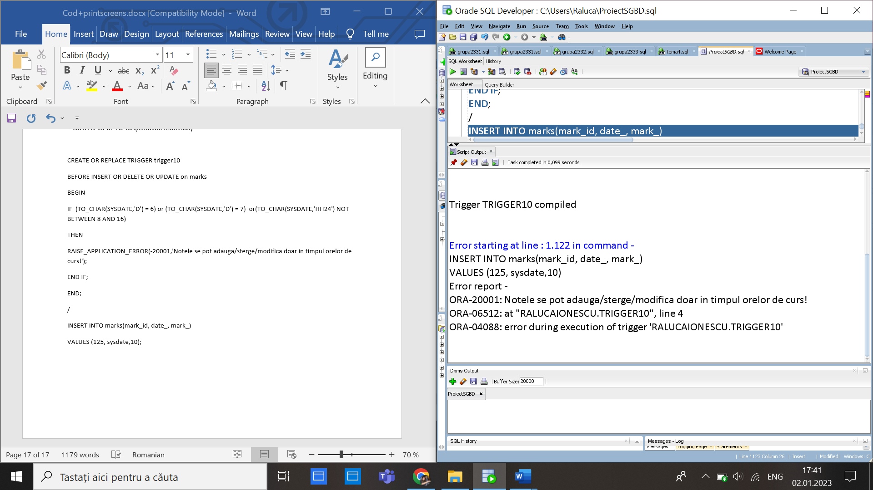

--11. Definiti un trigger de tip LMD la nivel de linie. Declansati trigger-ul.

--trigger care nu permite schimbarea tipului unei clase in amfiteatru daca capacitatea salii nu este cel putin 50

CREATE OR REPLACE TRIGGER trigger11

BEFORE UPDATE ON classroom

FOR EACH ROW

BEGIN

if(:NEW.classroom_type <> :OLD.classroom_type and :old.capacityy<50)then

RAISE_APPLICATION_ERROR (-20000, 'Nu puteti modifica descrierea unei sali de clasa cu mai putin de 50 de locuri intr-un amfiteatru!');

end if;

END;

/

UPDATE classroom

SET classroom_type ='amfiteatru' --nu merge

where classroom_id=80;

UPDATE classroom

SET classroom_type ='amfiteatru' --se modifica

where classroom_id=84;

select * from classroom;

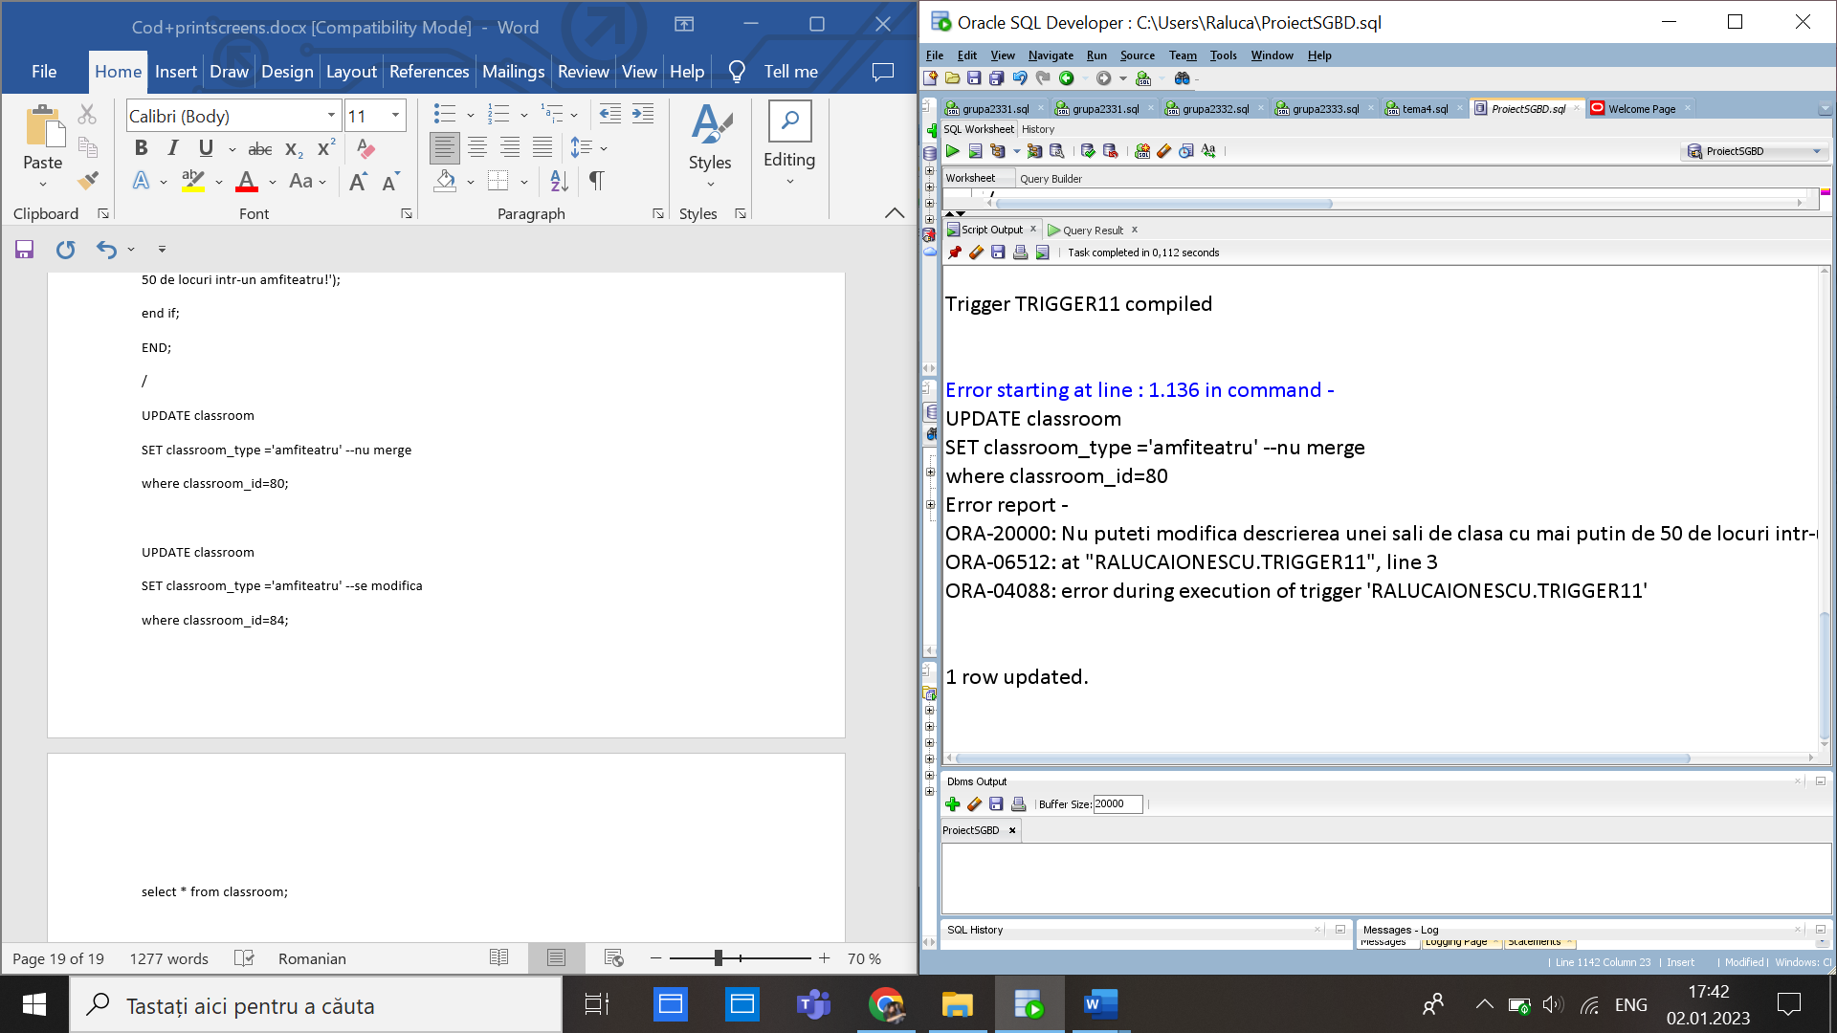

--12. Definiti un trigger de tip LDD. Declansati trigger-ul.

--trigger care salveaza modificari in audit_userr la comenzi de create,alter,drop

CREATE TABLE audit_userr

(nume_bazadate VARCHAR2(50),

user_logat VARCHAR2(50),

eveniment VARCHAR2(50),

tip_obiect VARCHAR2(50),

nume_obiect VARCHAR2(50),

data date

);

CREATE OR REPLACE TRIGGER ex12

AFTER CREATE OR DROP OR ALTER ON SCHEMA

BEGIN

INSERT INTO audit_userr

VALUES (SYS.DATABASE_NAME, SYS.LOGIN_USER,

SYS.SYSEVENT, SYS.DICTIONARY_OBJ_TYPE,

SYS.DICTIONARY_OBJ_NAME, sysdate);

END;

/

CREATE TABLE tip_nou_angajat(id_angajat number(3),

job_name varchar2(50),

job_description varchar2(200));

ALTER TABLE tip_nou_angajat ADD (coloana number(2));

INSERT INTO tip_nou_angajat VALUES (1,'angajat_nou', 'responsabil de cladirea X',2);

SELECT * FROM audit_userr;

